**Module 5: *Lab 1 Using MVC Middleware Security**

Saurabh Kale

IFT 458/554: Middleware Programming & Database Security

Dinesh Sthapit

Oct 22th, 2023

**SECTION 1**

1. Project Directory Structure

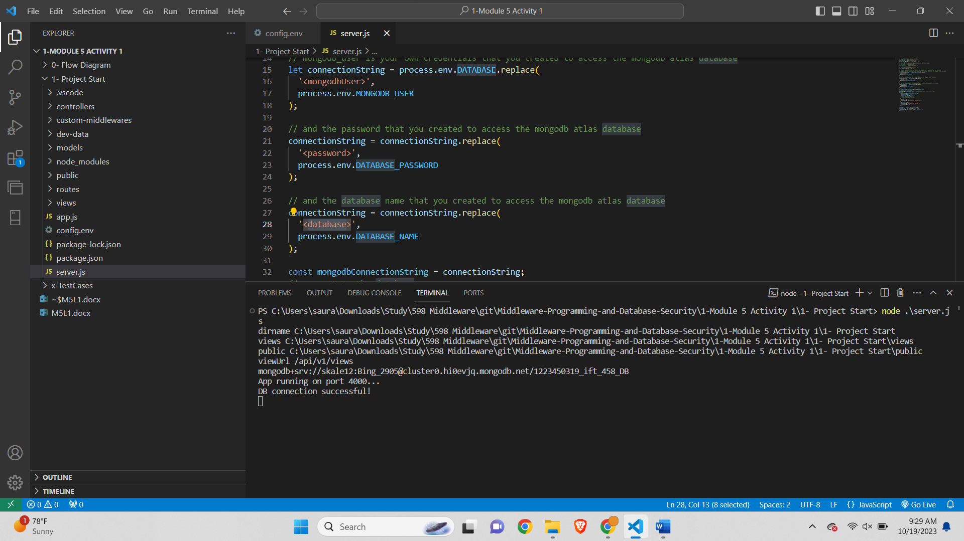

1. Connection failed with error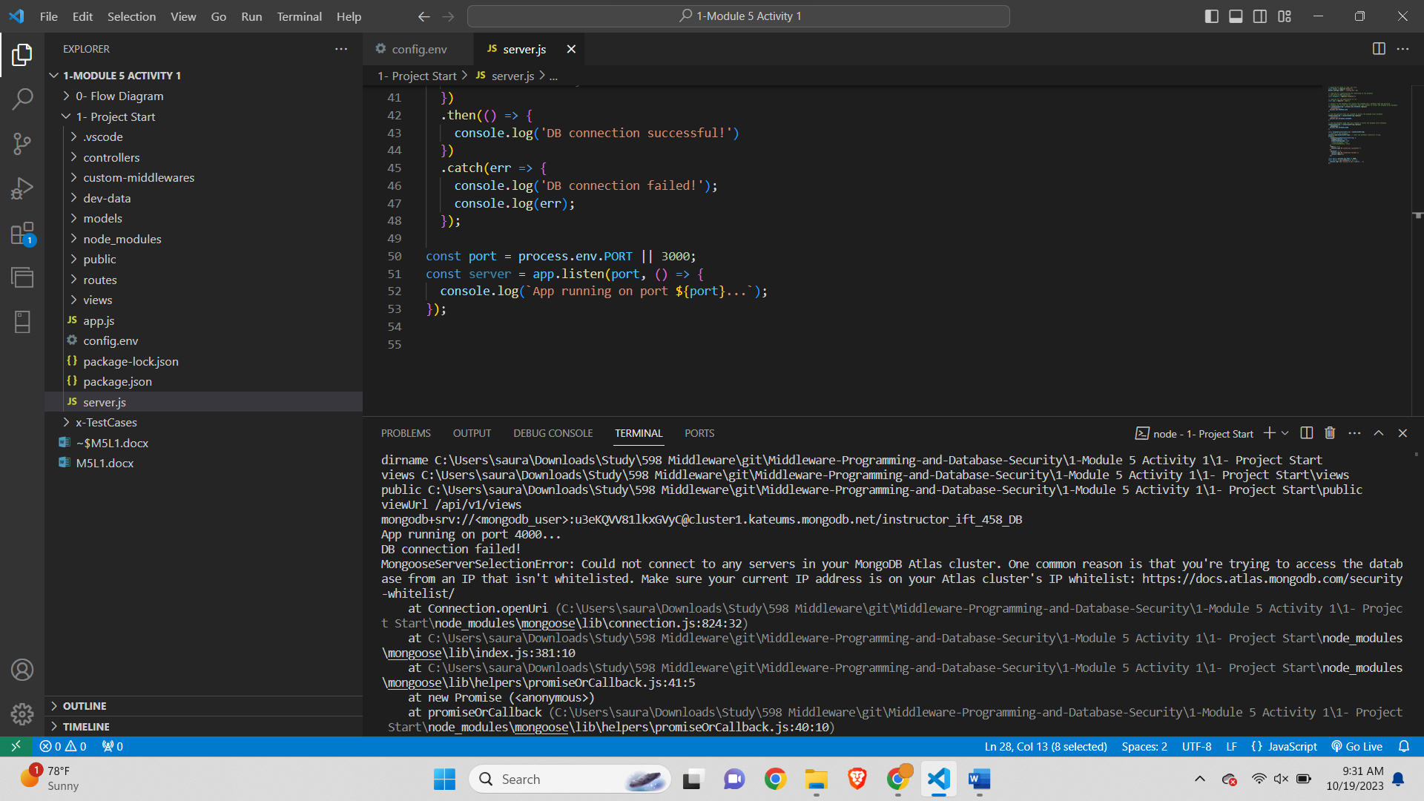
2. Config.env for working code-

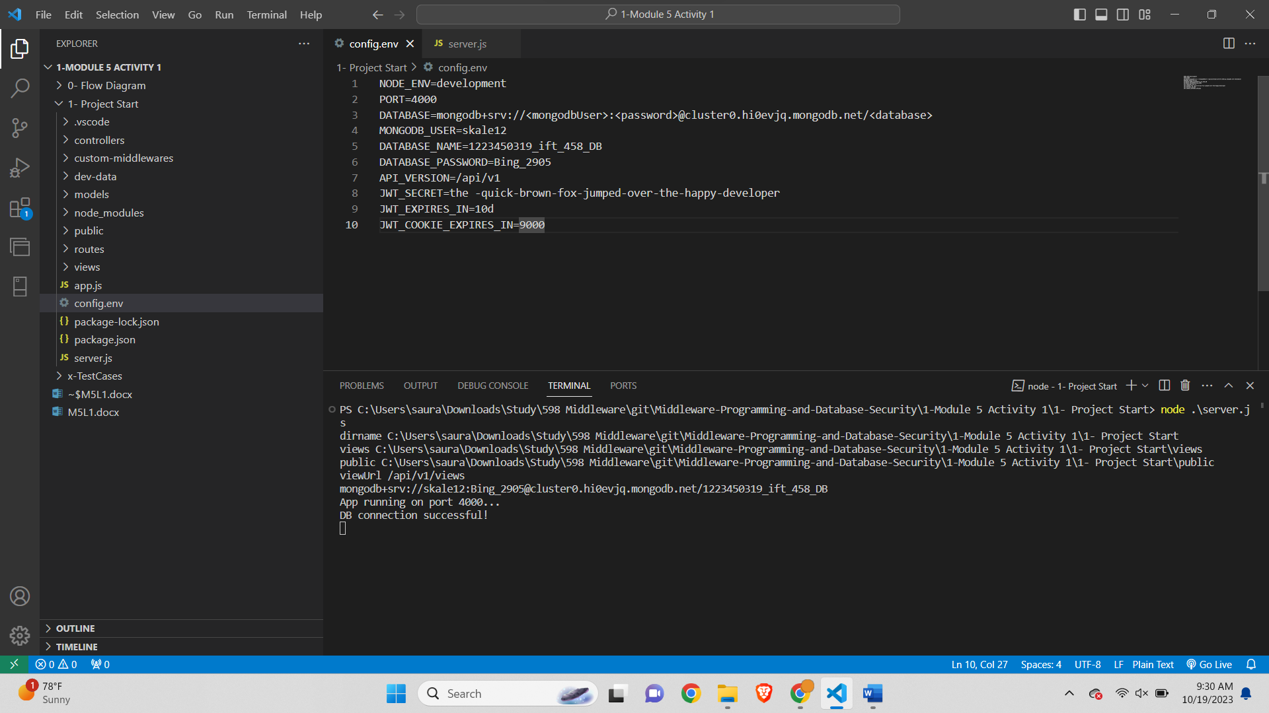



**SECTION 2**

**Task 1**-   **You will be creating a Debug breakpoint in the code**

1st Breakpoint point -

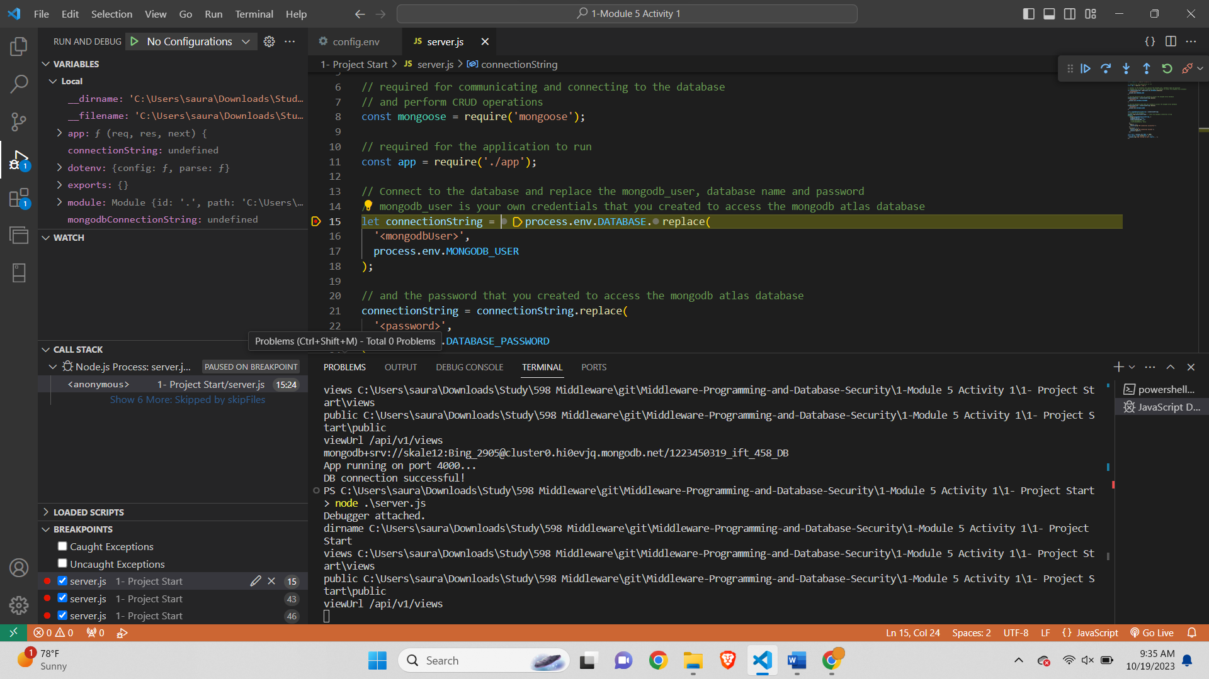

In this part of code we have fetched the DATABASE string from config.env and replaced <mongodbUser> with the value MONGODB_USER set in config.env

2nd (a) breakpoint point -

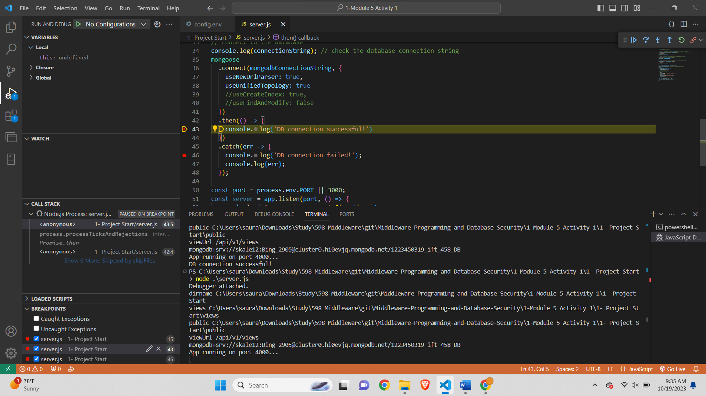

This part of code runs when the DB connection for MongoDB is successful

2nd (b) Breakpoint point -

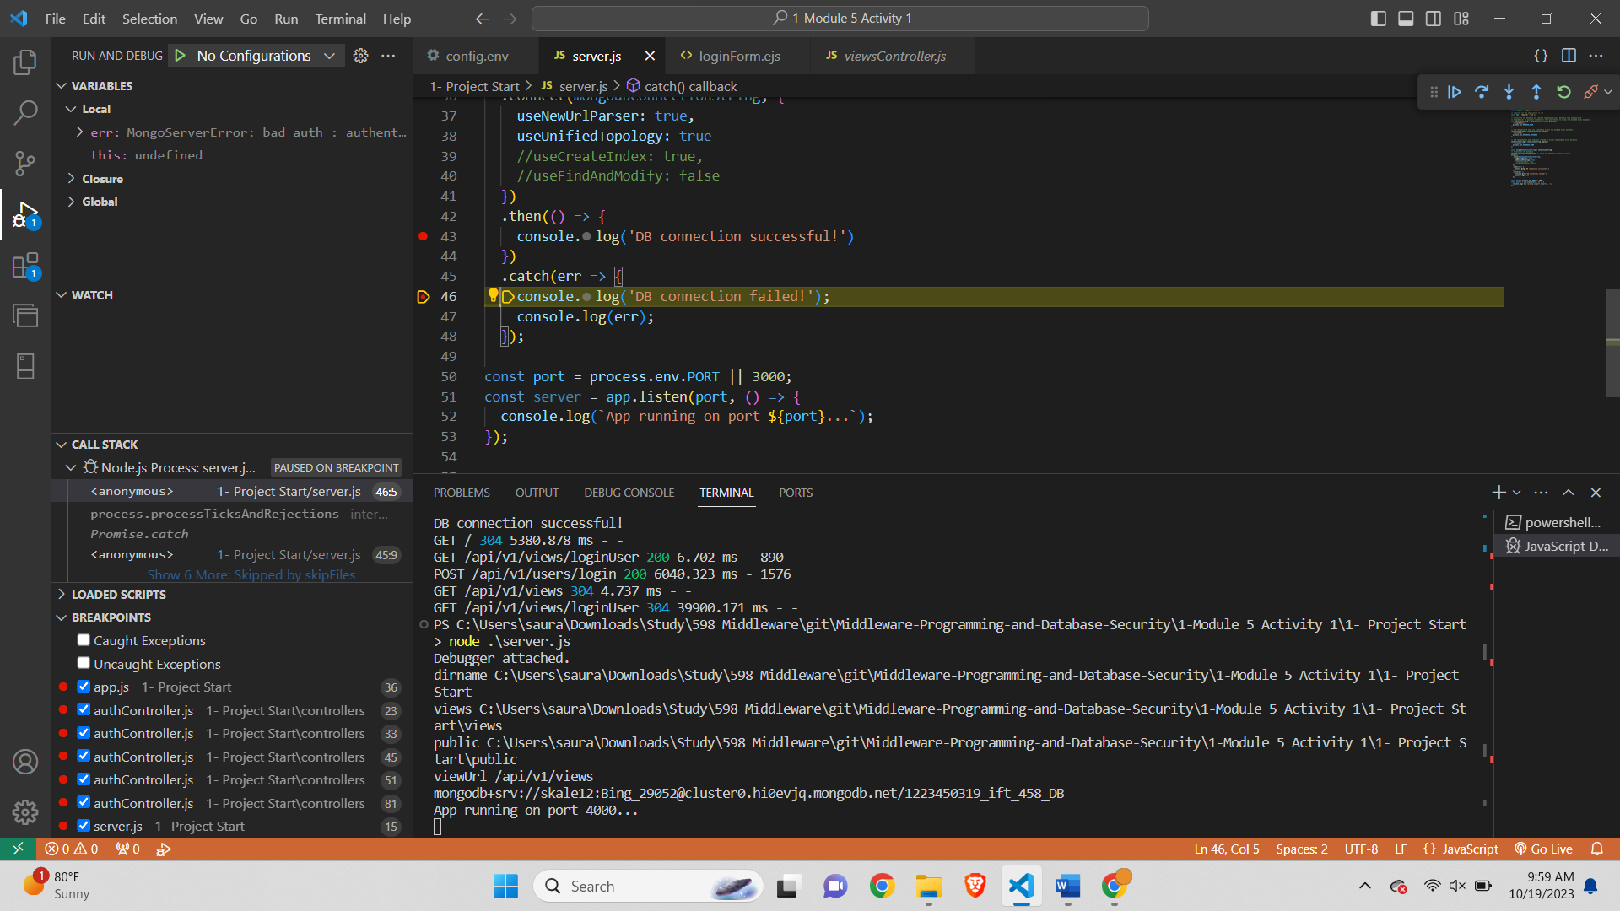

This part of code is reached when there is any error in connecting MongoDb server. It can be user credentials.

3rd Breakpoint point -

Locate app.js

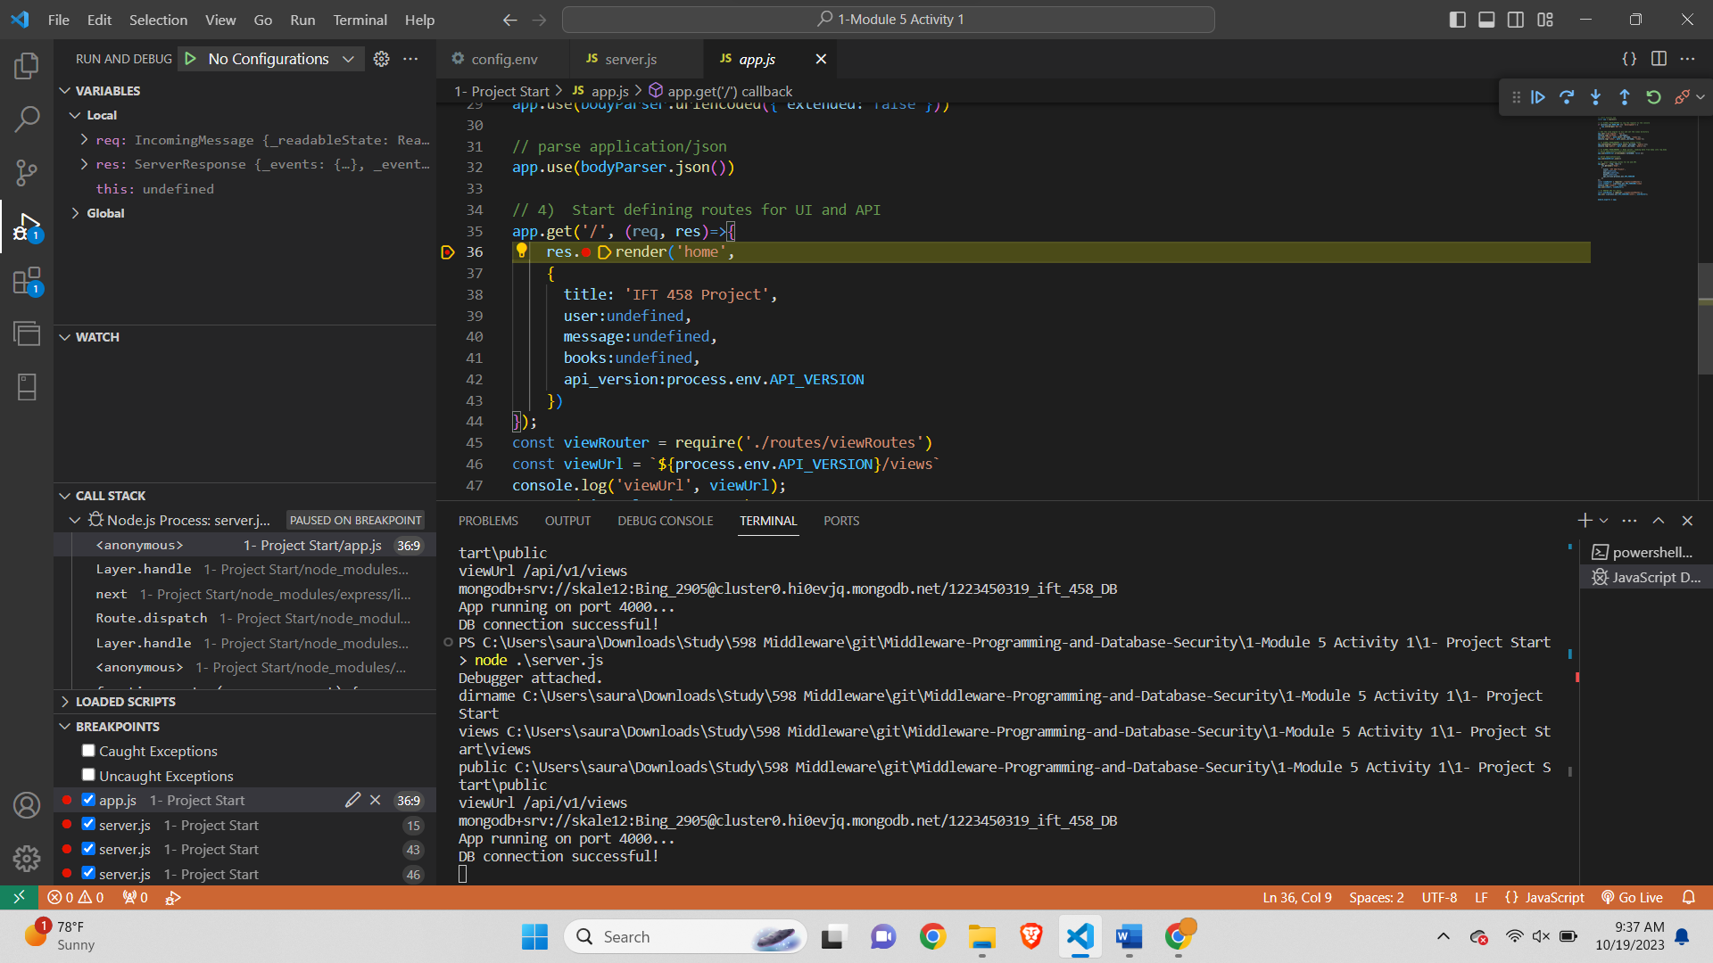

This part of code is reached when we load the home page after succesfully runnning the server

Signup page-

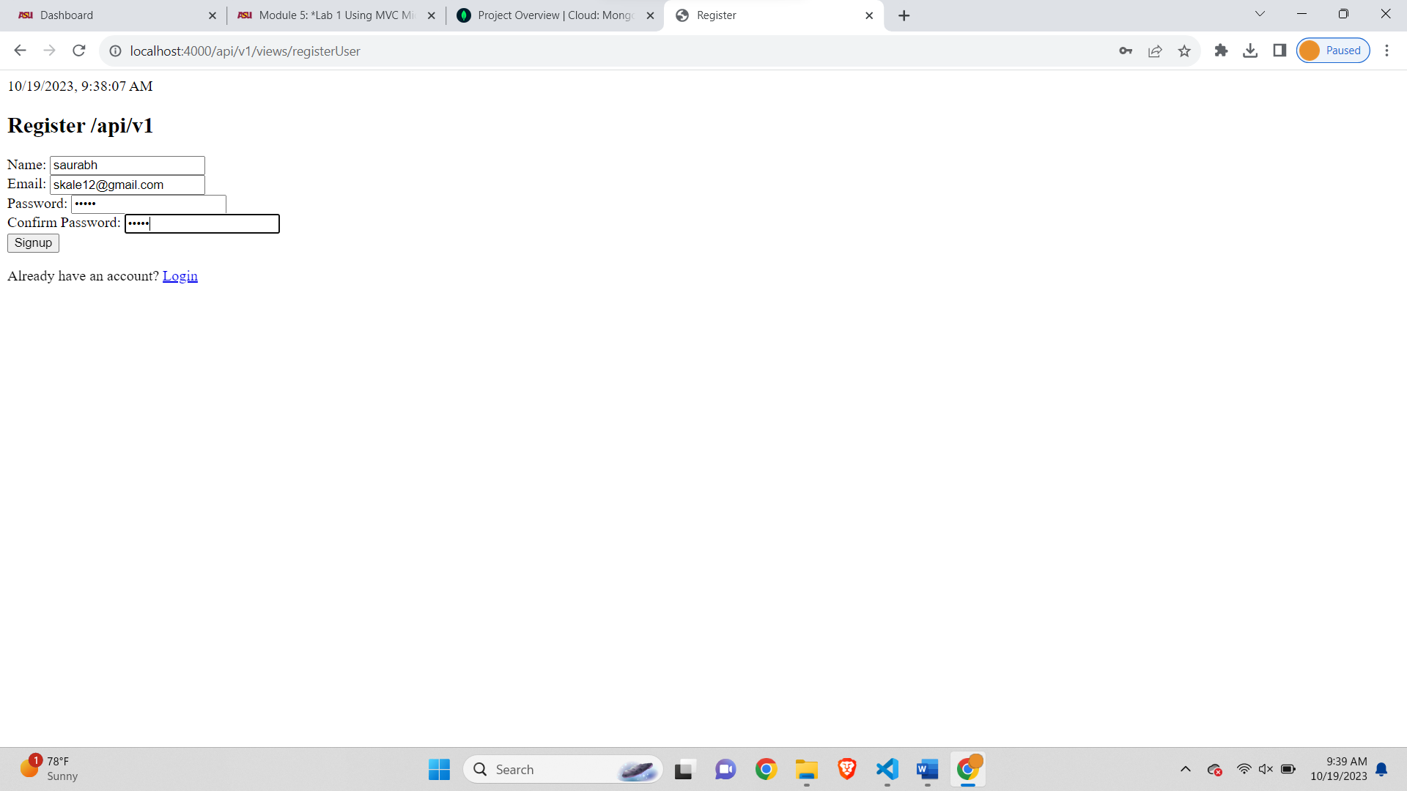

4th Debugger point-

Signup debugger-

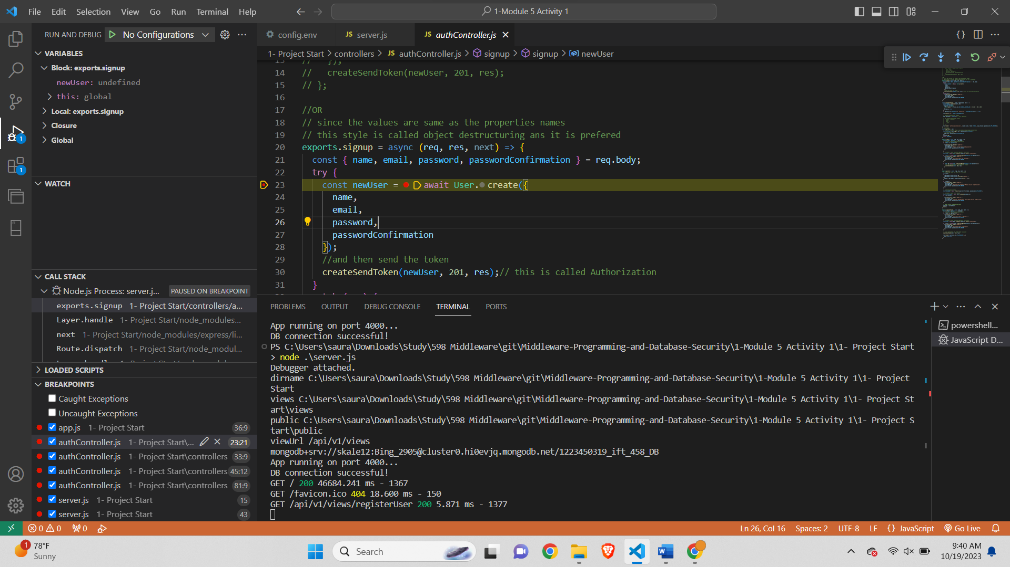

This part of code is reached when the user enters signup details and clicks submit button

5th debugger point-

Catch api error-

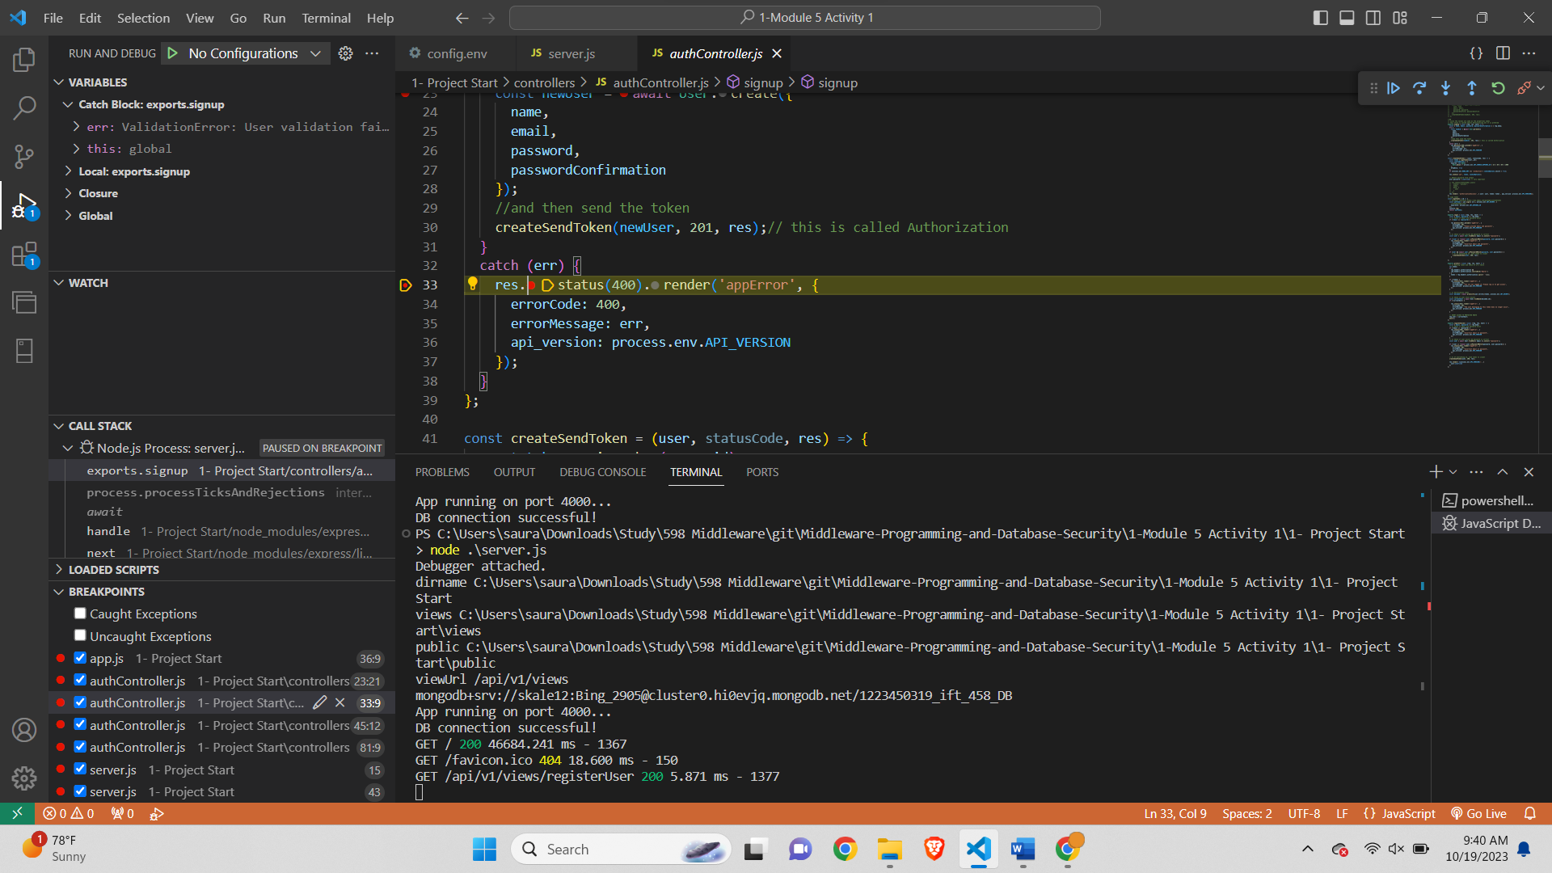

Error screenshot-

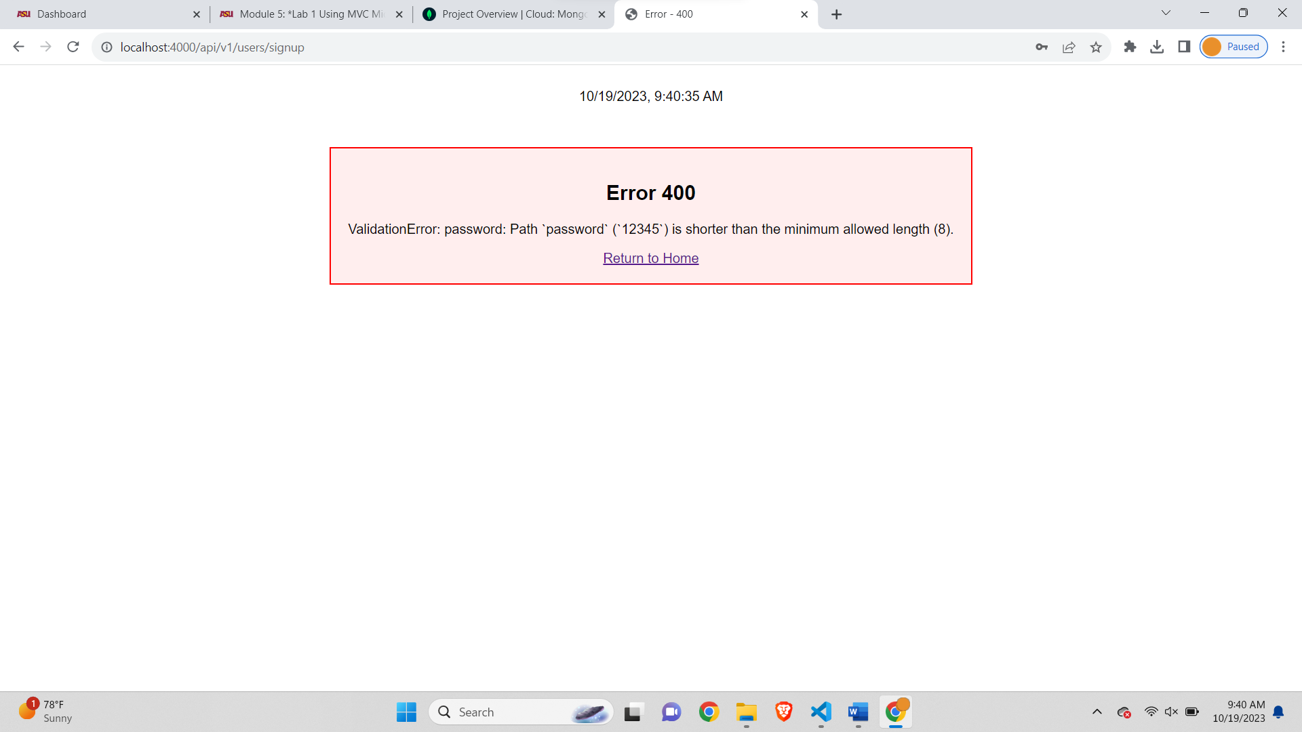

6th (a) debugger point-

After successful Signup-

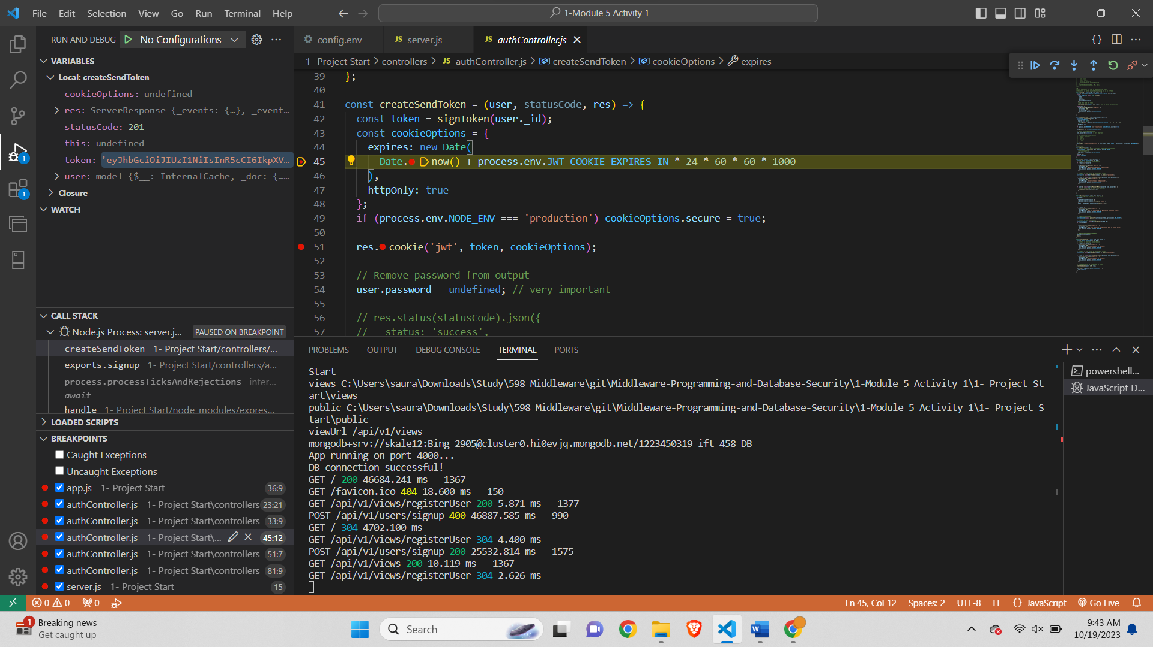

6th (b) debugger point-

Sending token

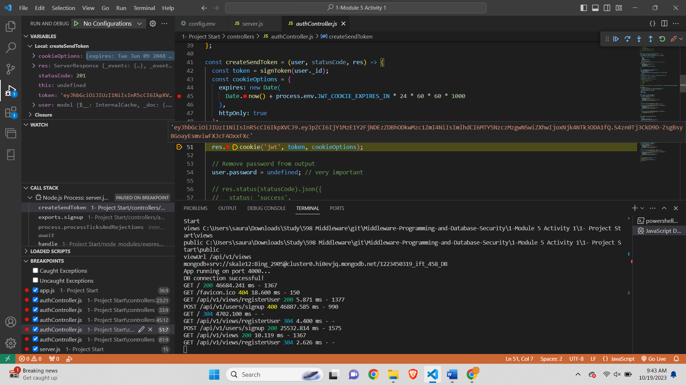

After successful signup-

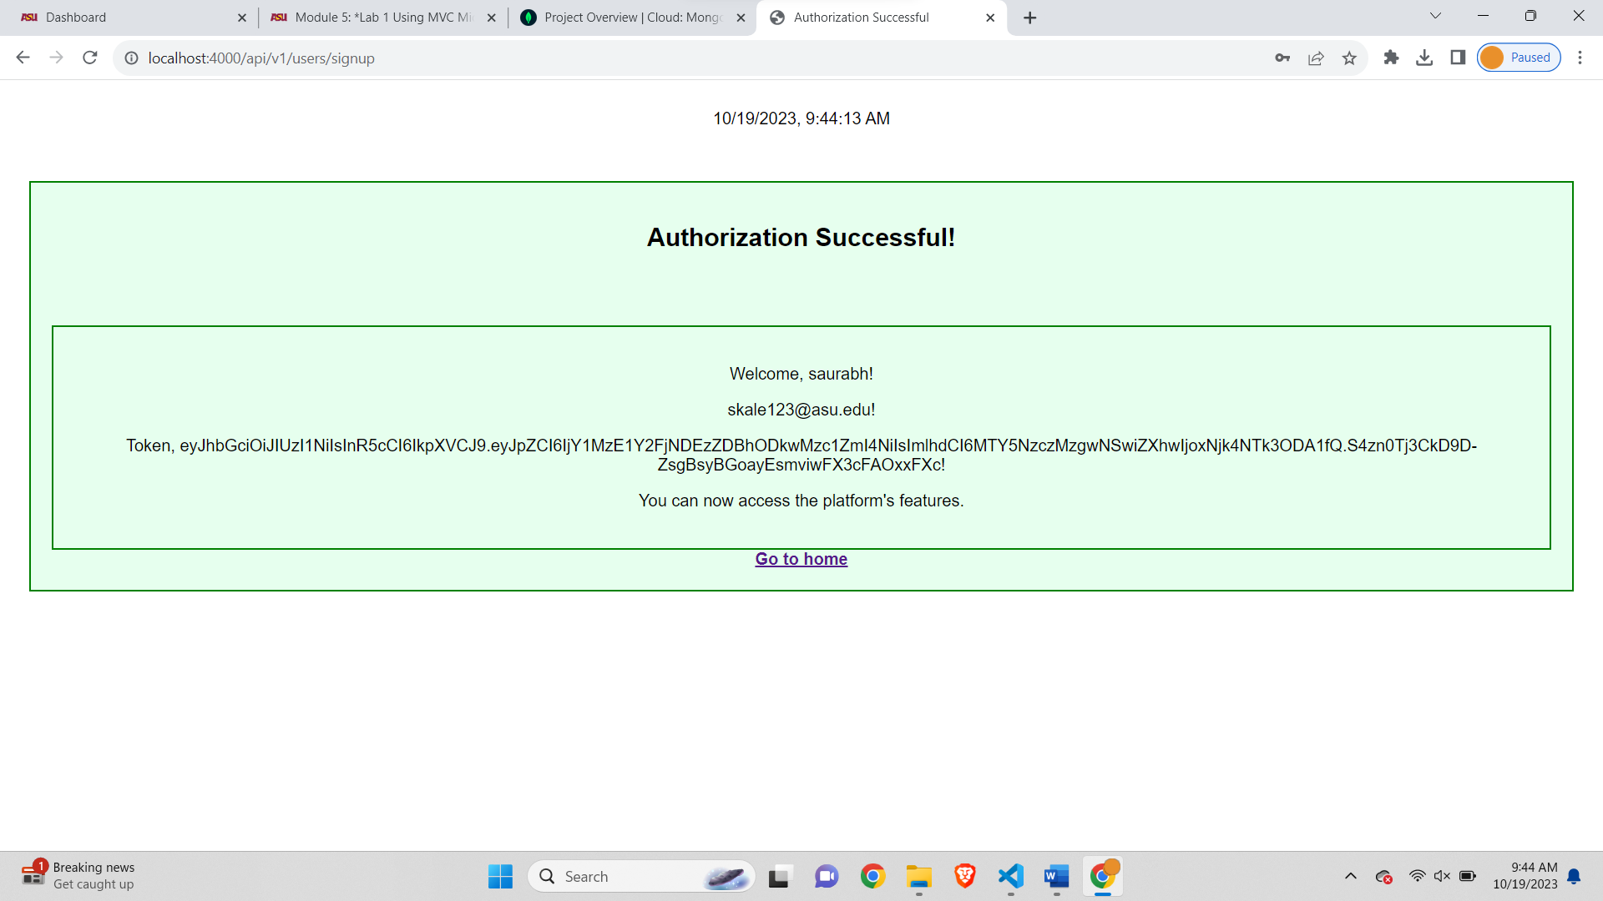

7th Debugger point-

Breakpoint at login-

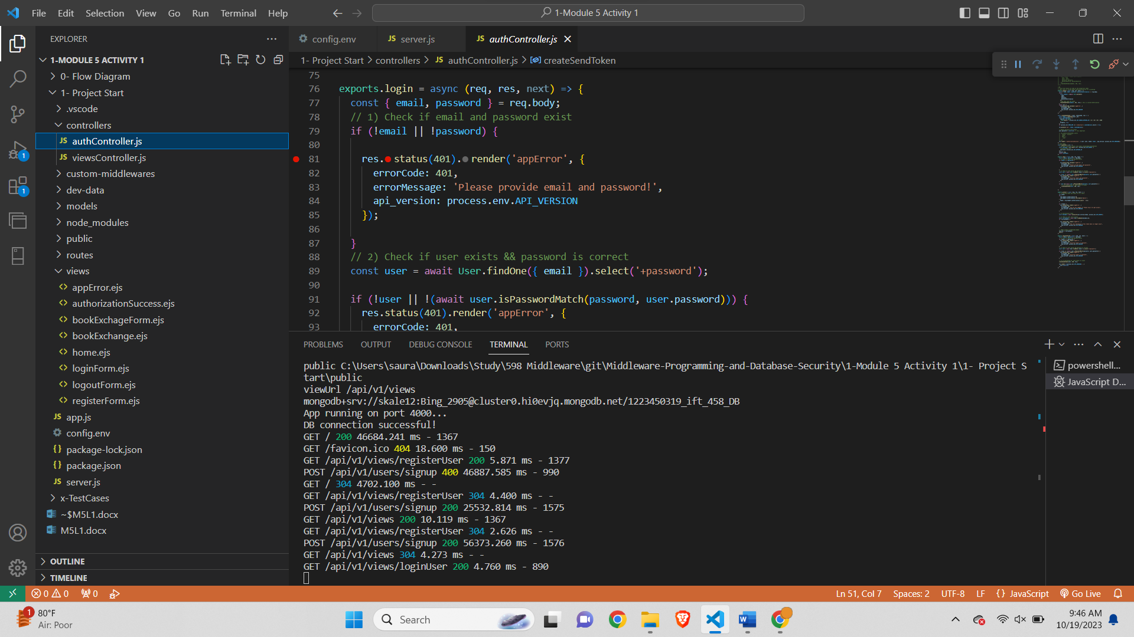

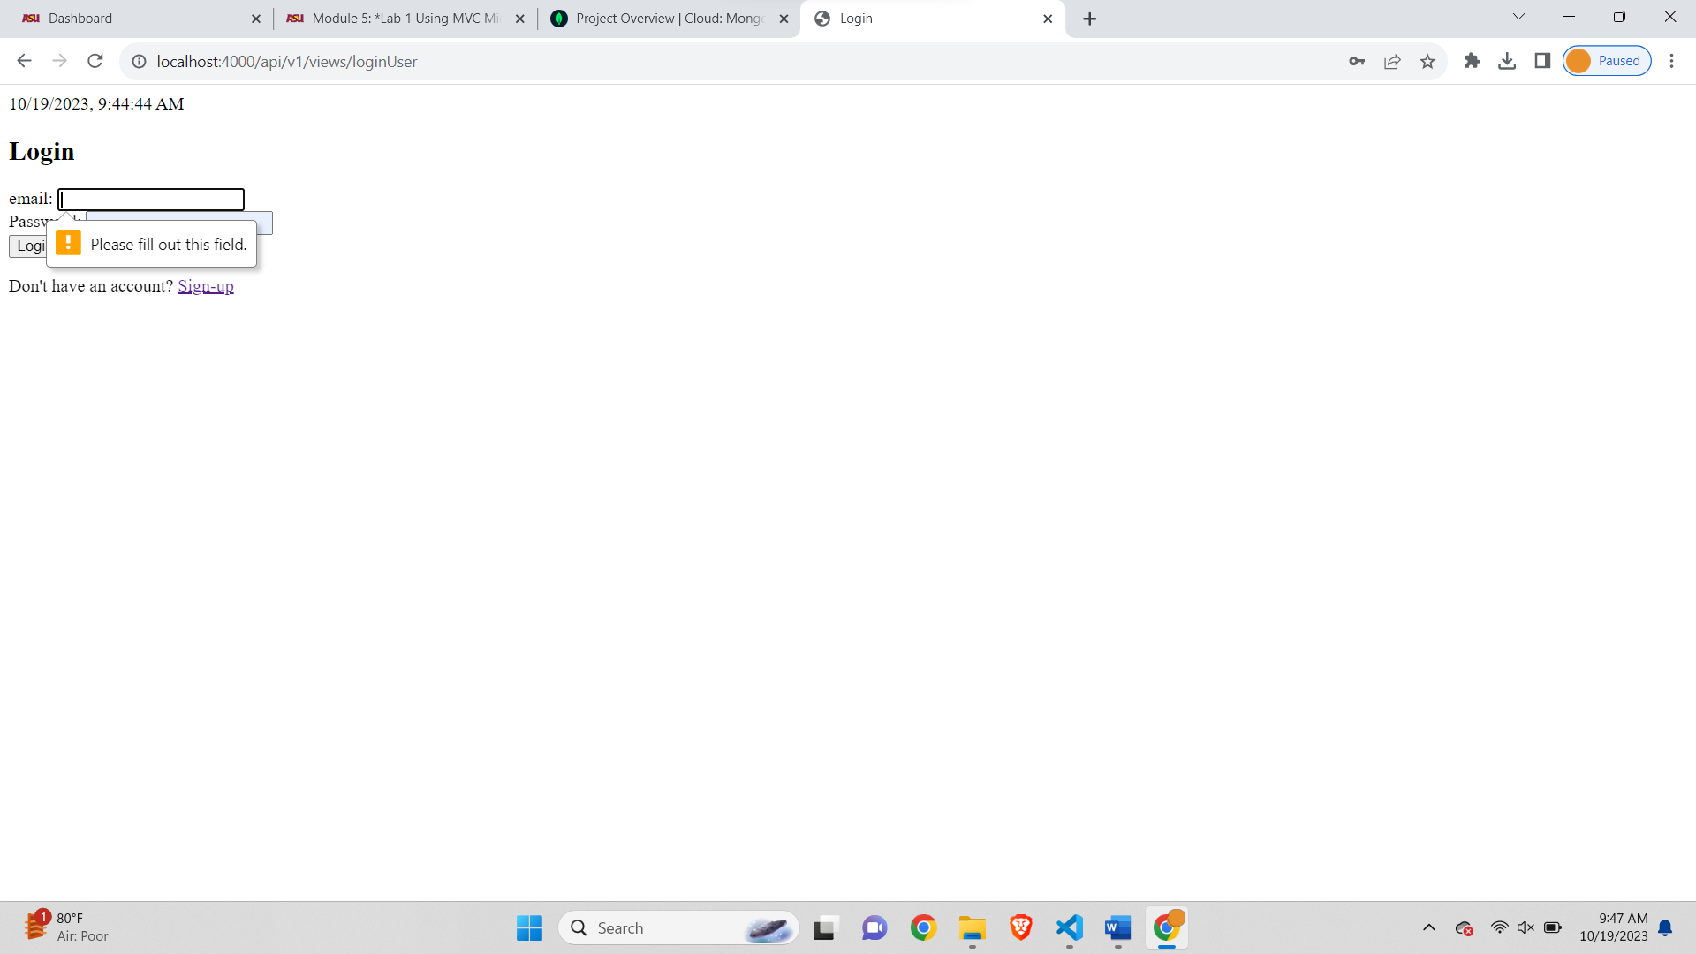

To catch the code at the debugger we will have to remove the required part in loginform for email or password element-

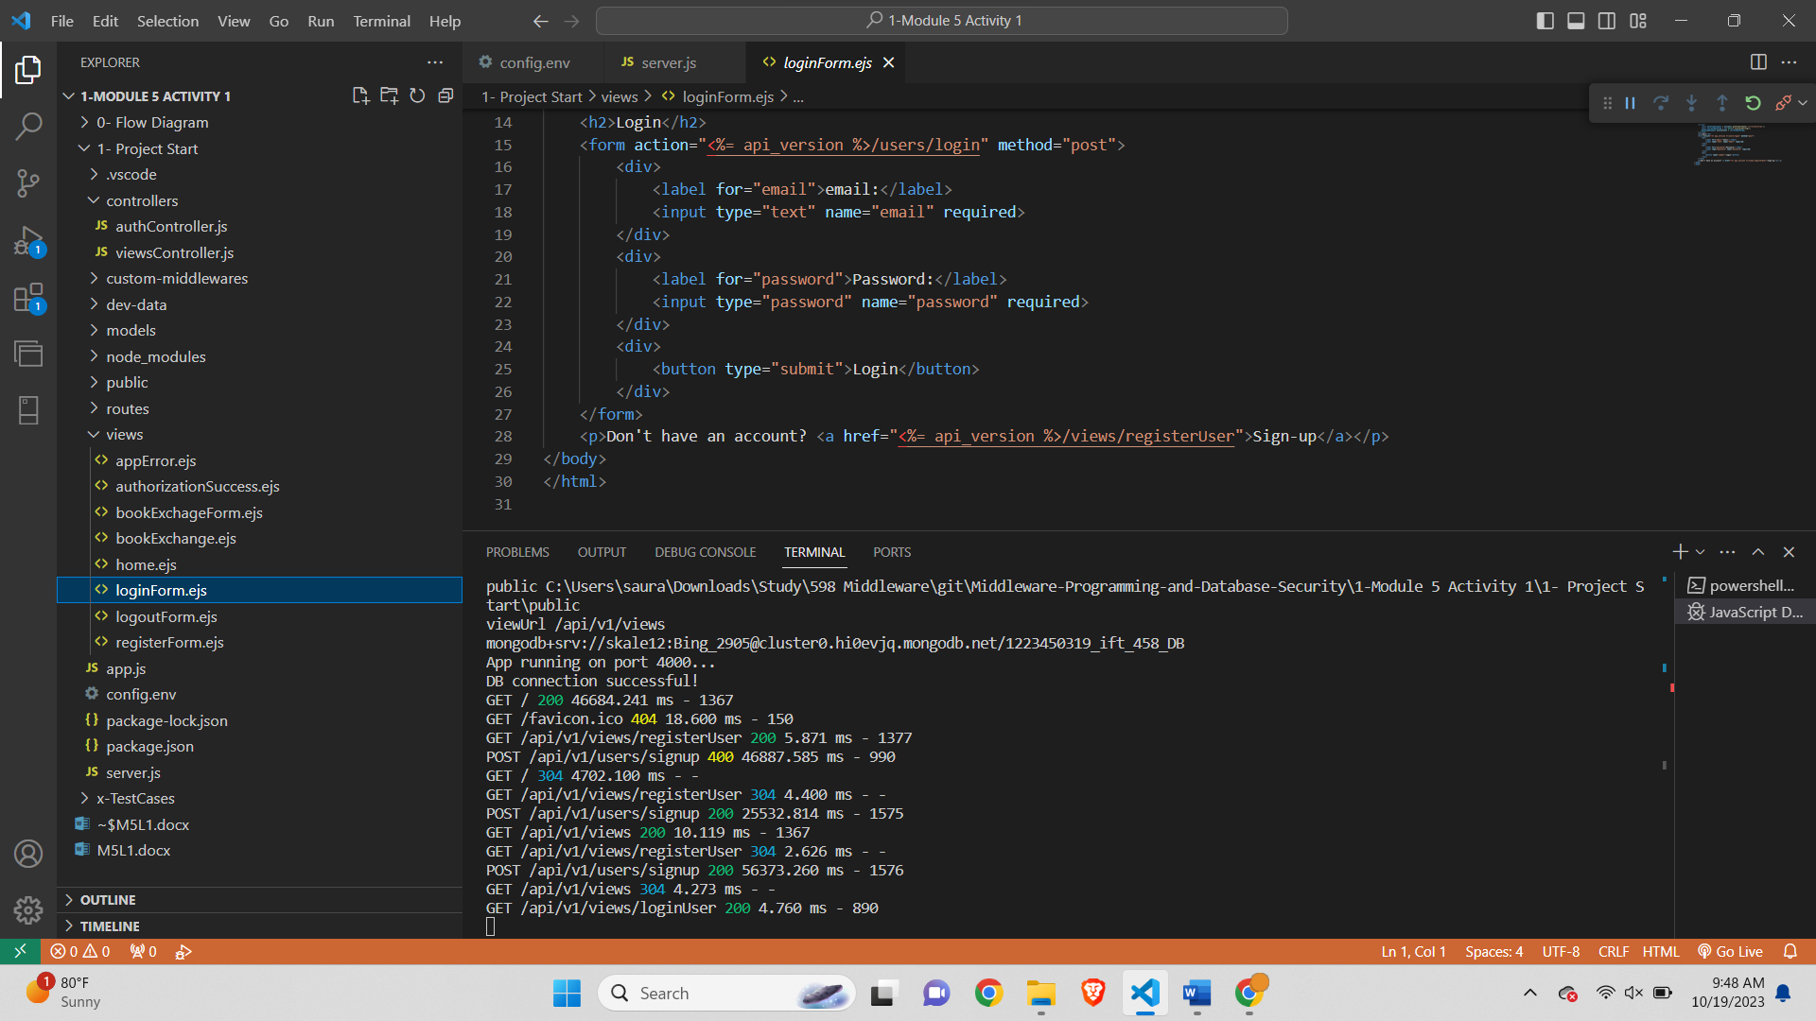

After removing one required-

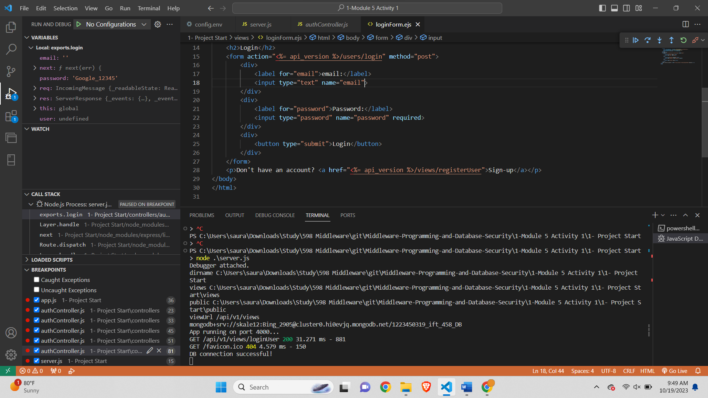

Debugger stuck at error-

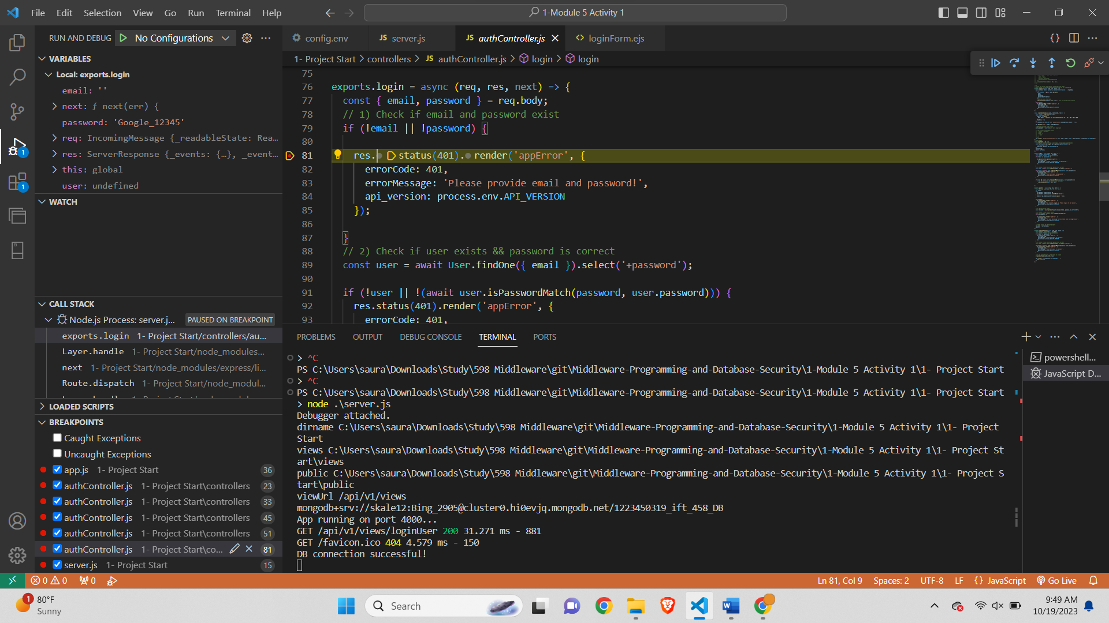

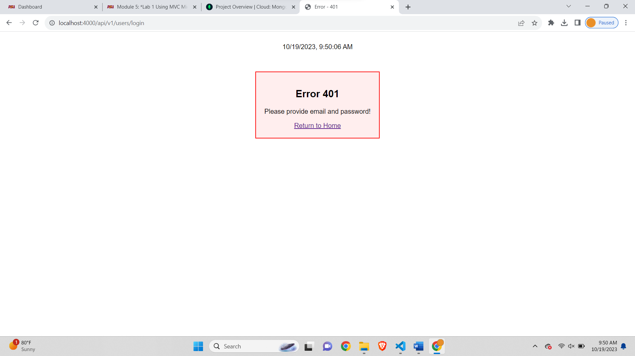

8th debugger point-

Create breakpoint for loginUser-

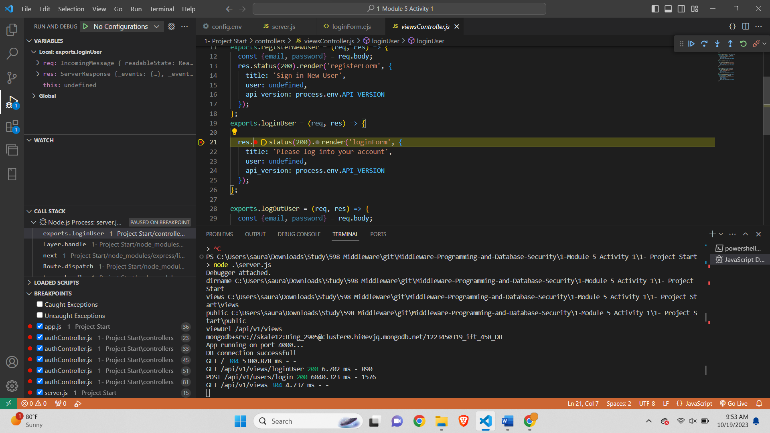

**SECTION 3-**

**Sequence diagram-**

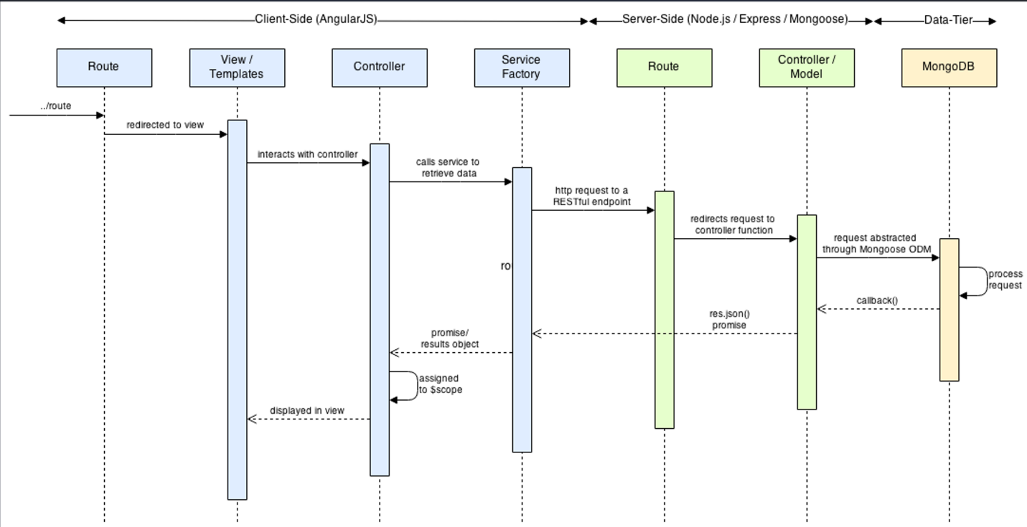

**TASK 1: Create a New User**

1. Identify the Links:

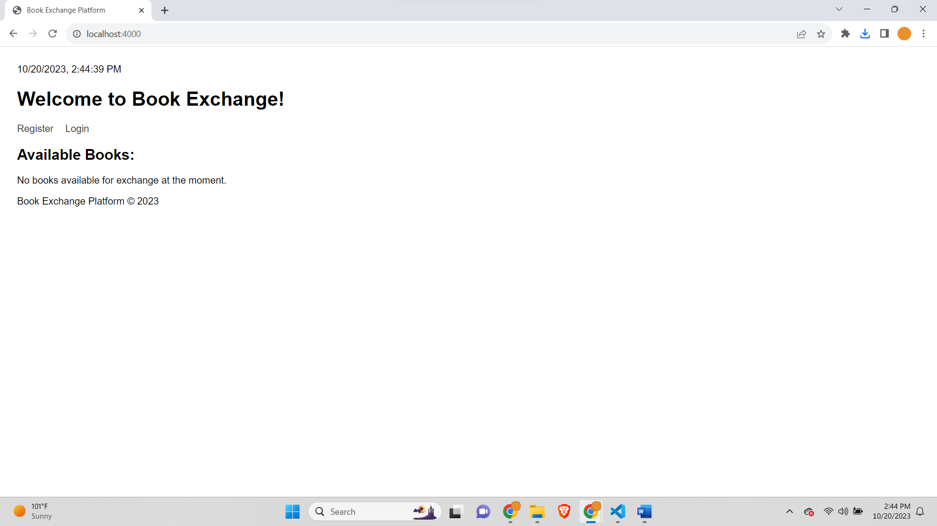

1. Initiate the Register Process-

Registration Page-  
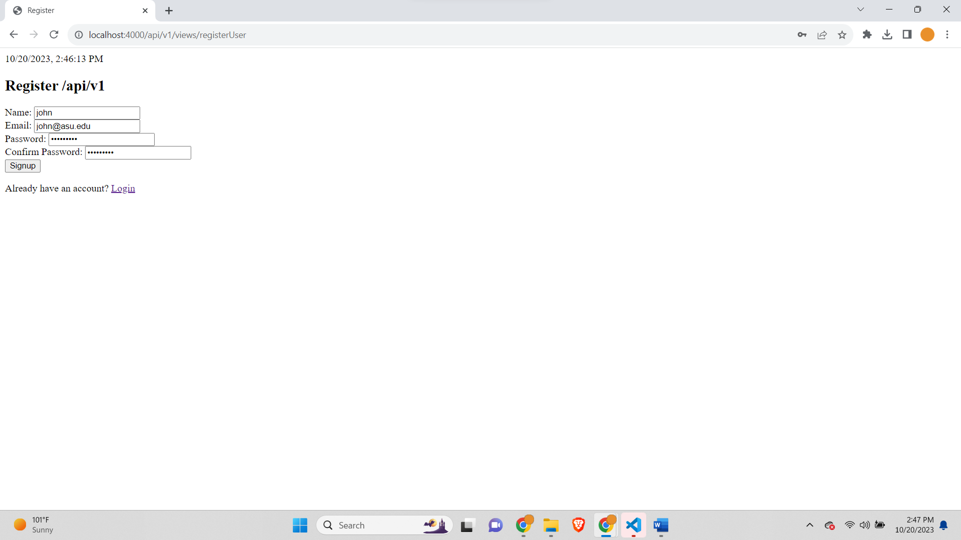

Breakpoint on clicking signup-

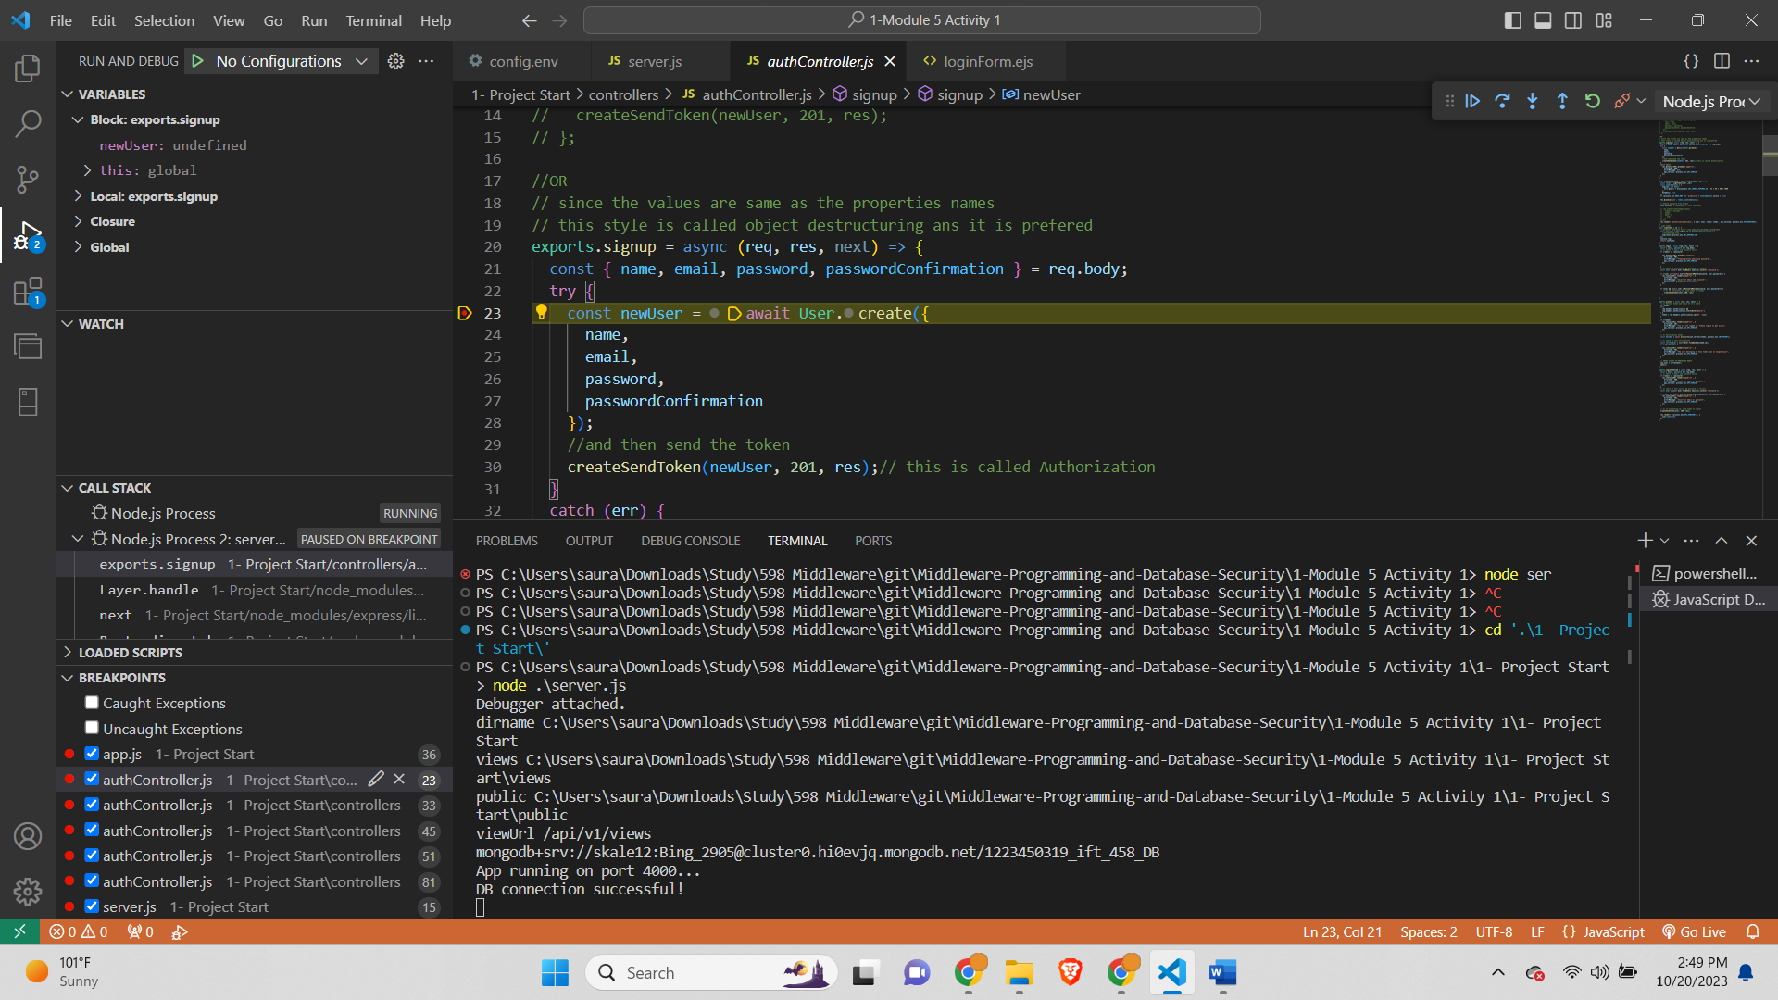

After signup-

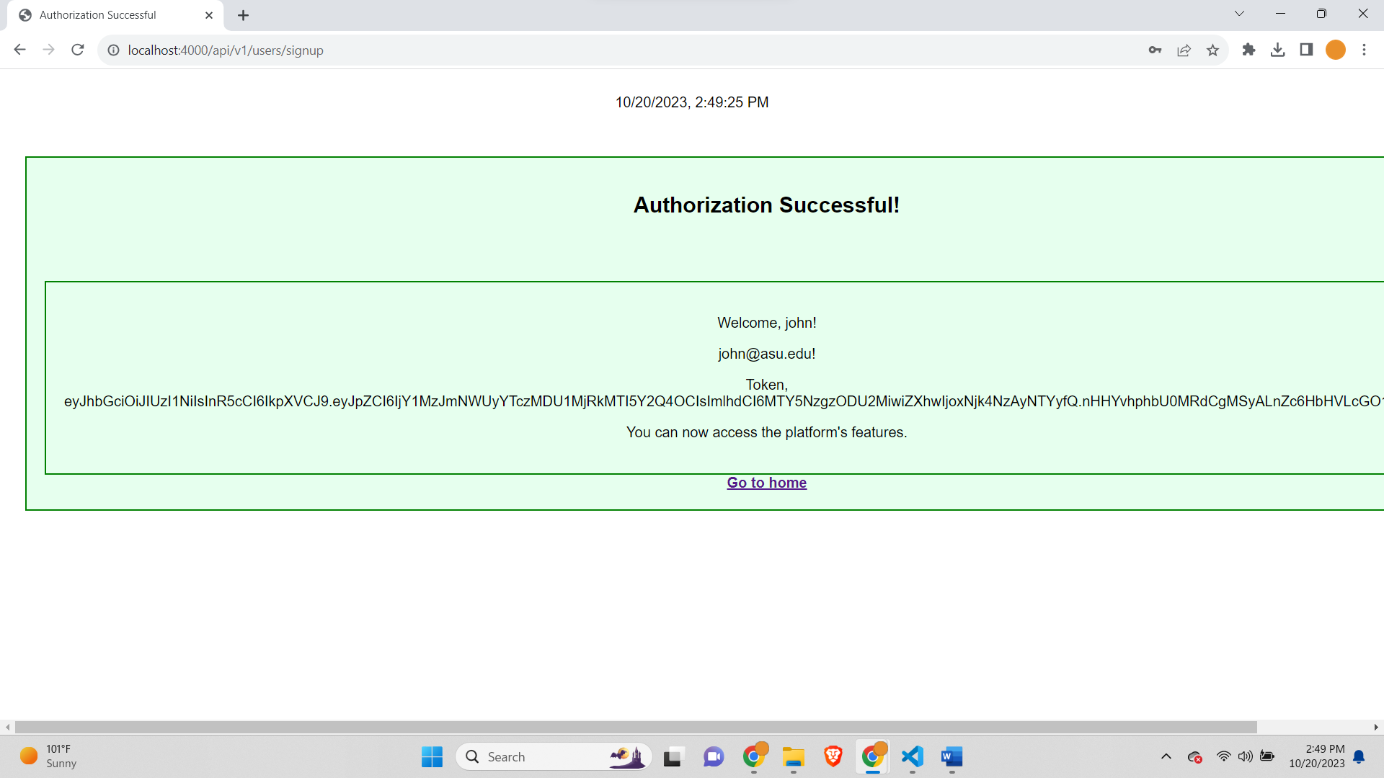

MongoDB Screenshot-

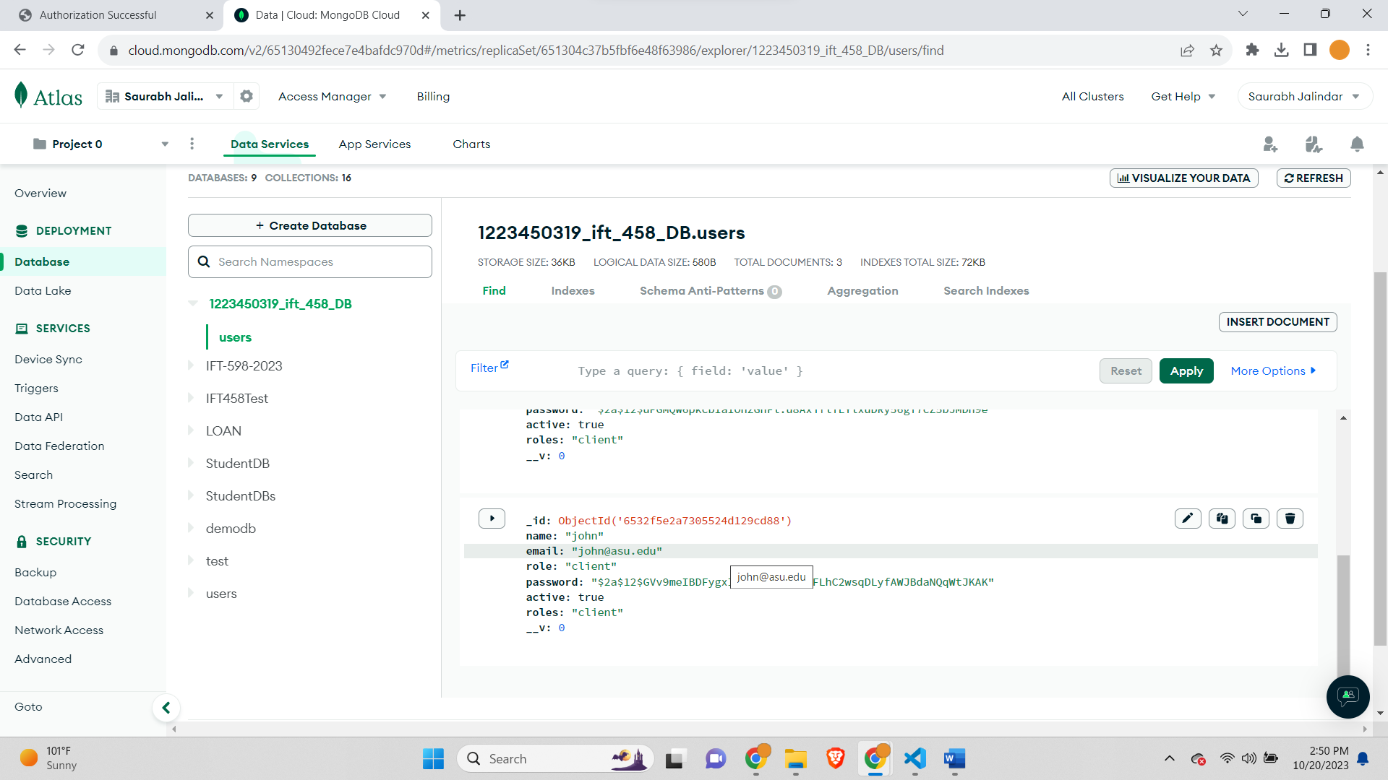

After Clicking on Login on home page-

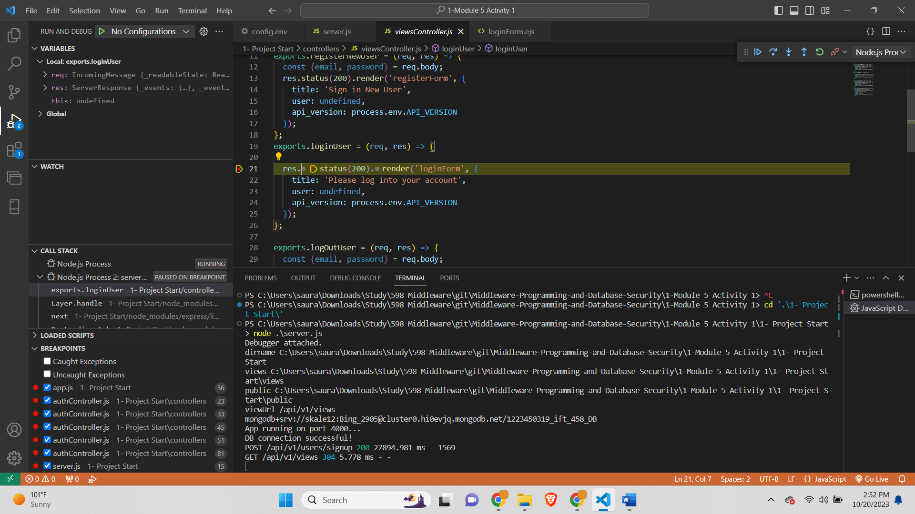

Login Page opens-

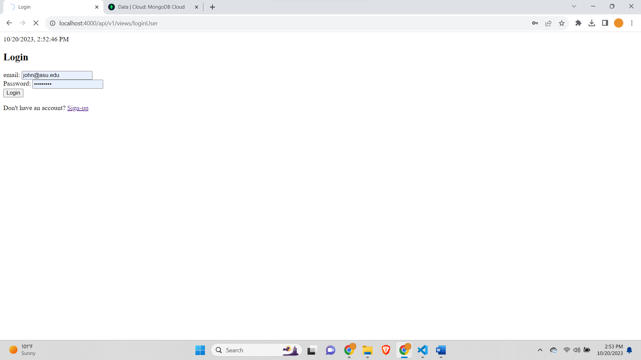

After entering details and clicking on login button this part of code is called-

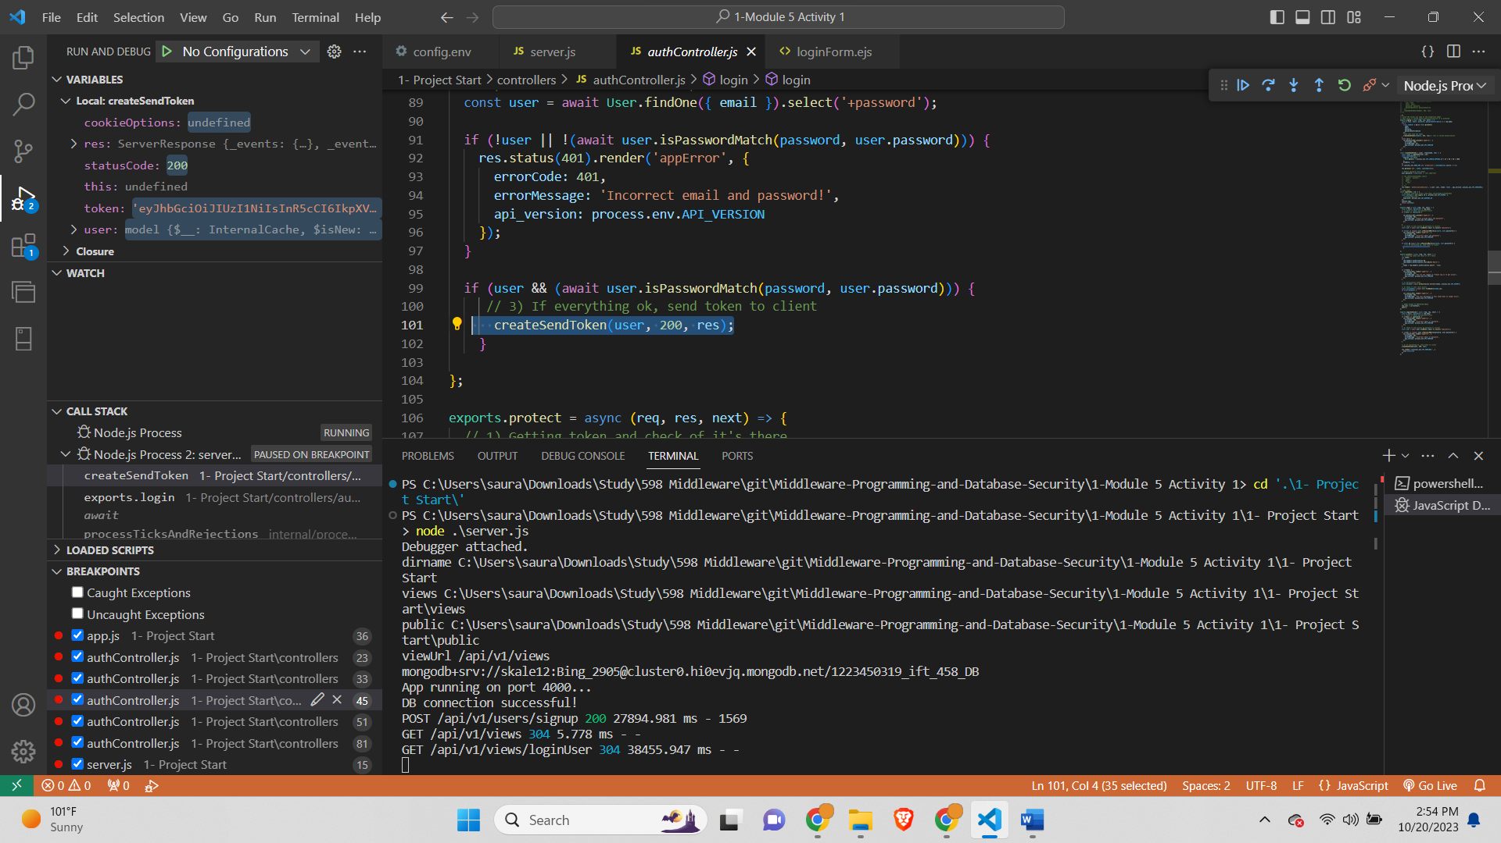

And we have added debugger in createSendToken where the code gets stucked-

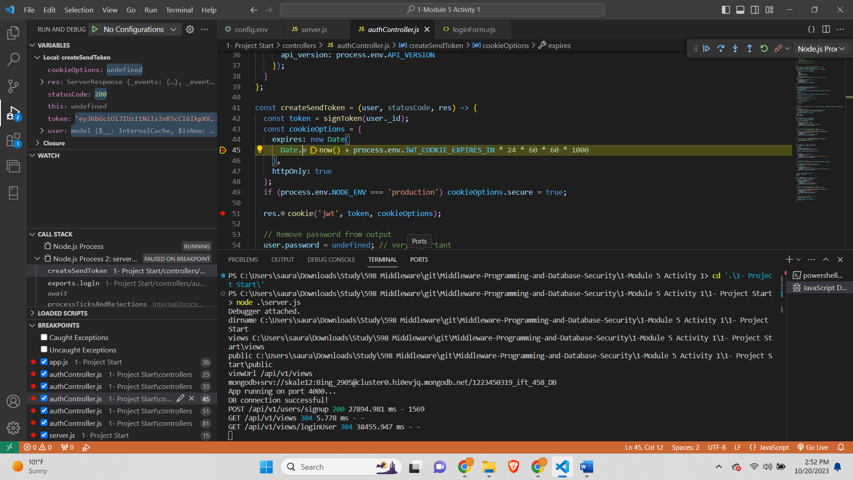

**TASK 2:**

Home page-

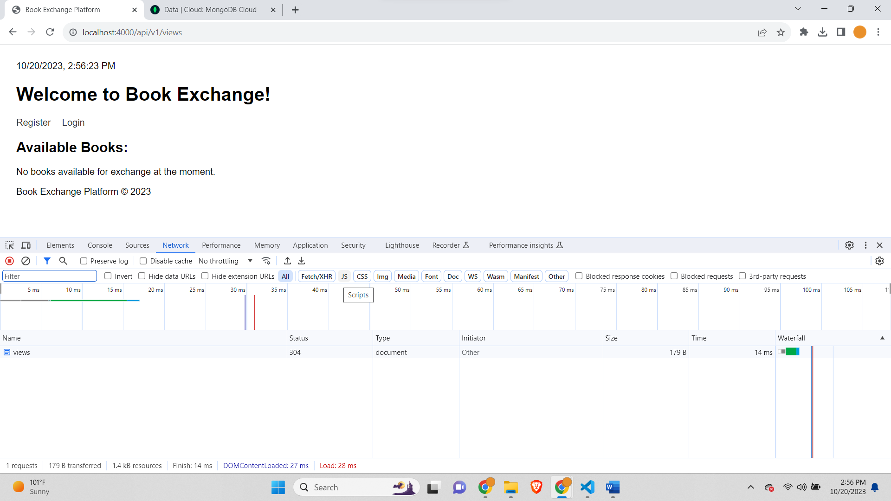

Register User-

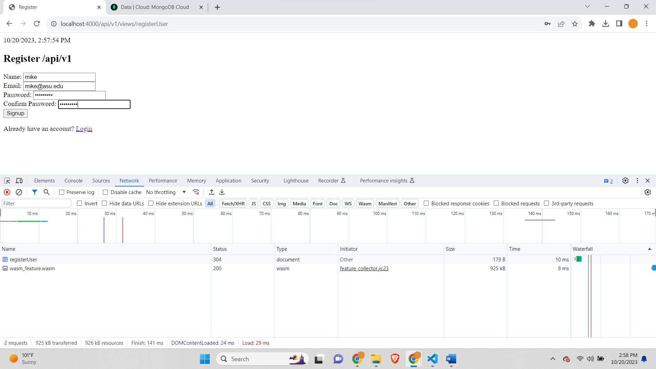

Jwtoken screenshot in response header-

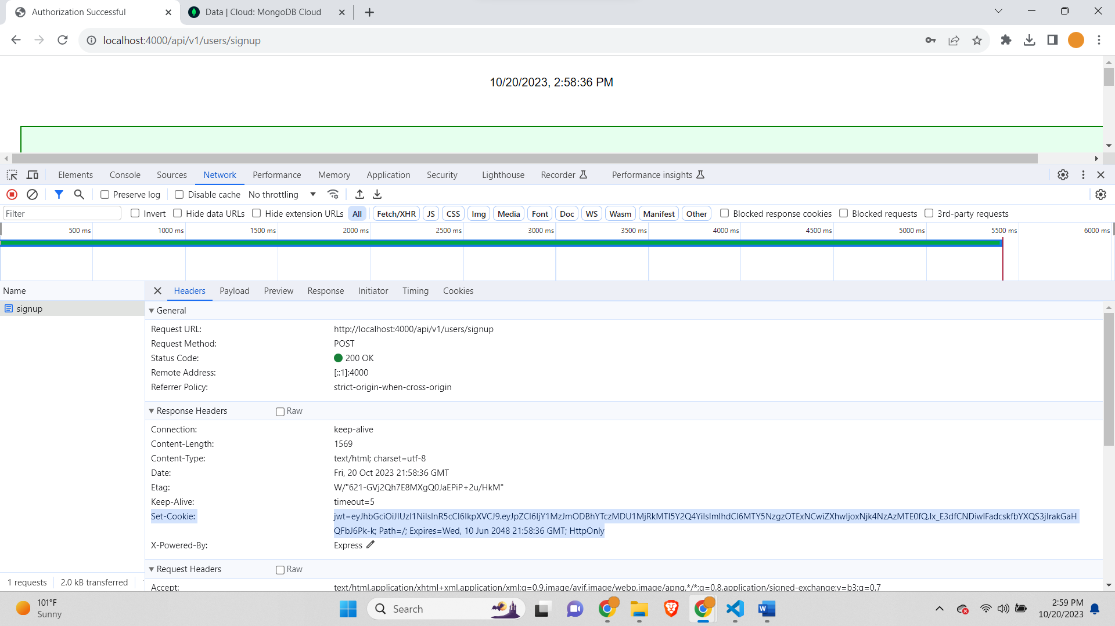

Jwtoken in request header-

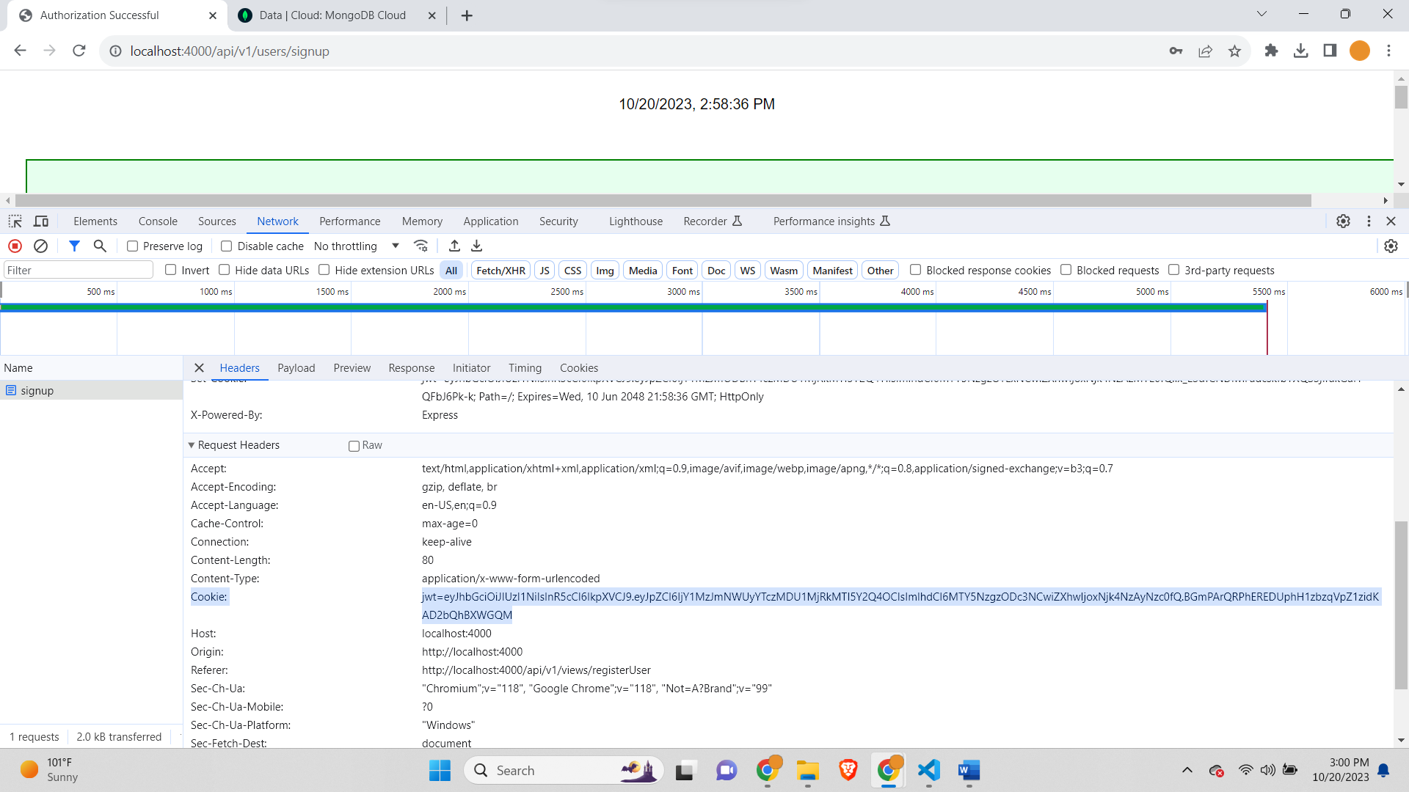

Screenshot of User Output-

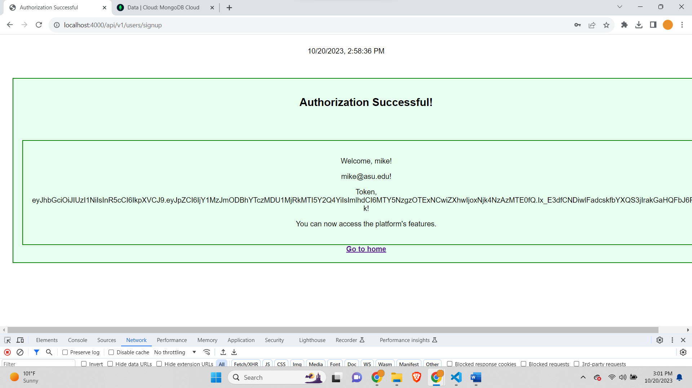

Again same thing for Login-

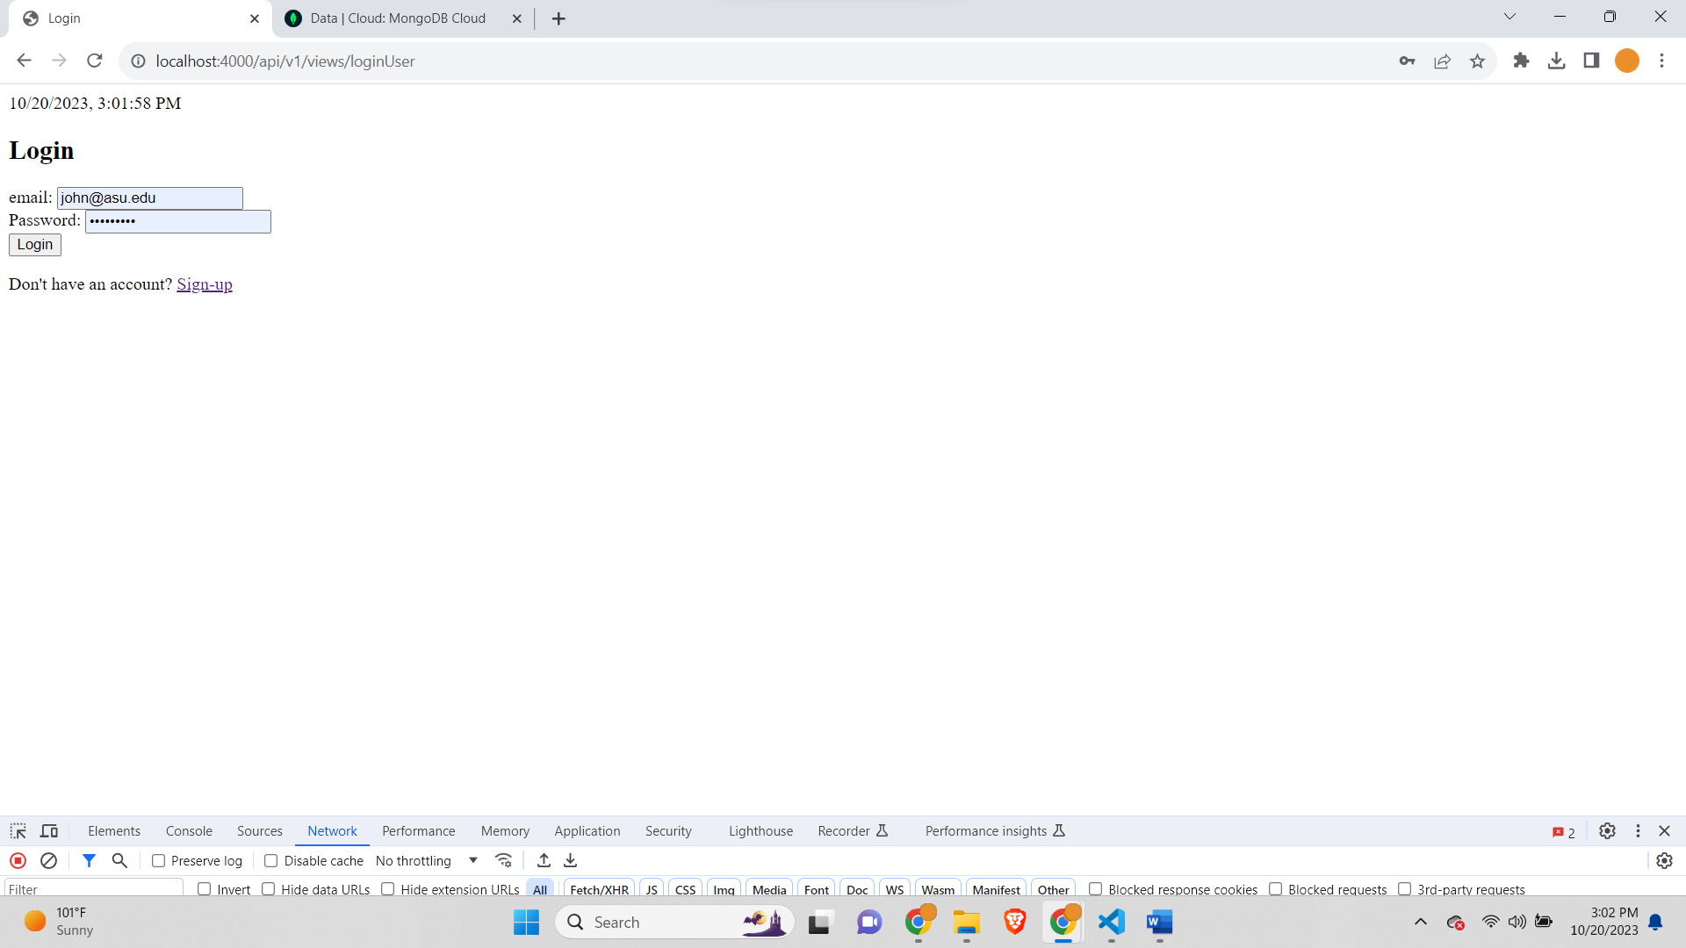

Jwtoken response header-

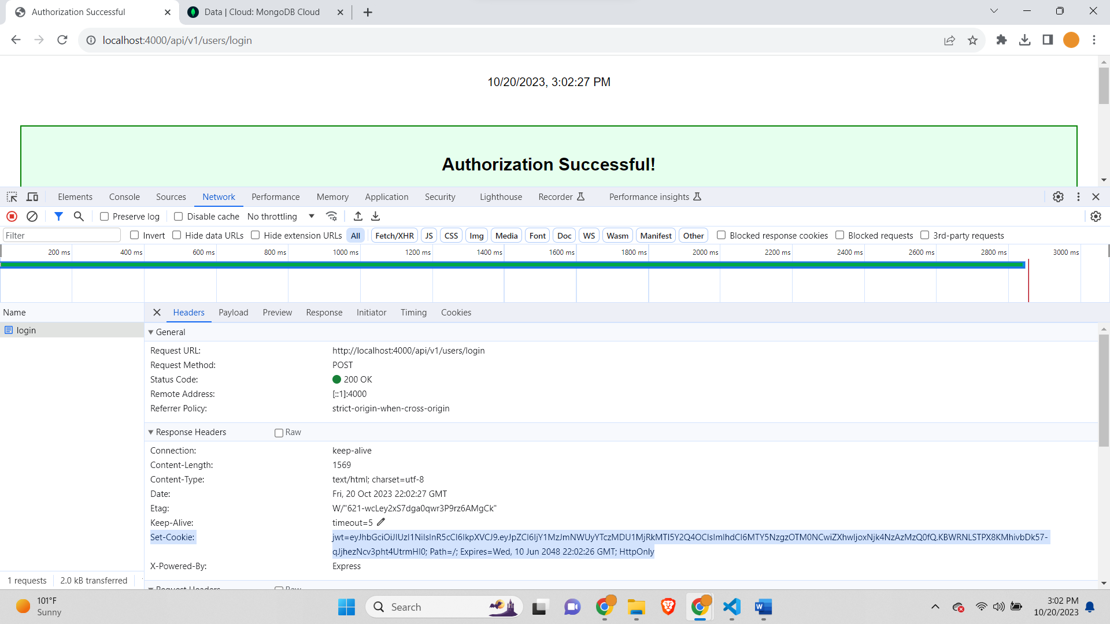

jwtoken in request header-

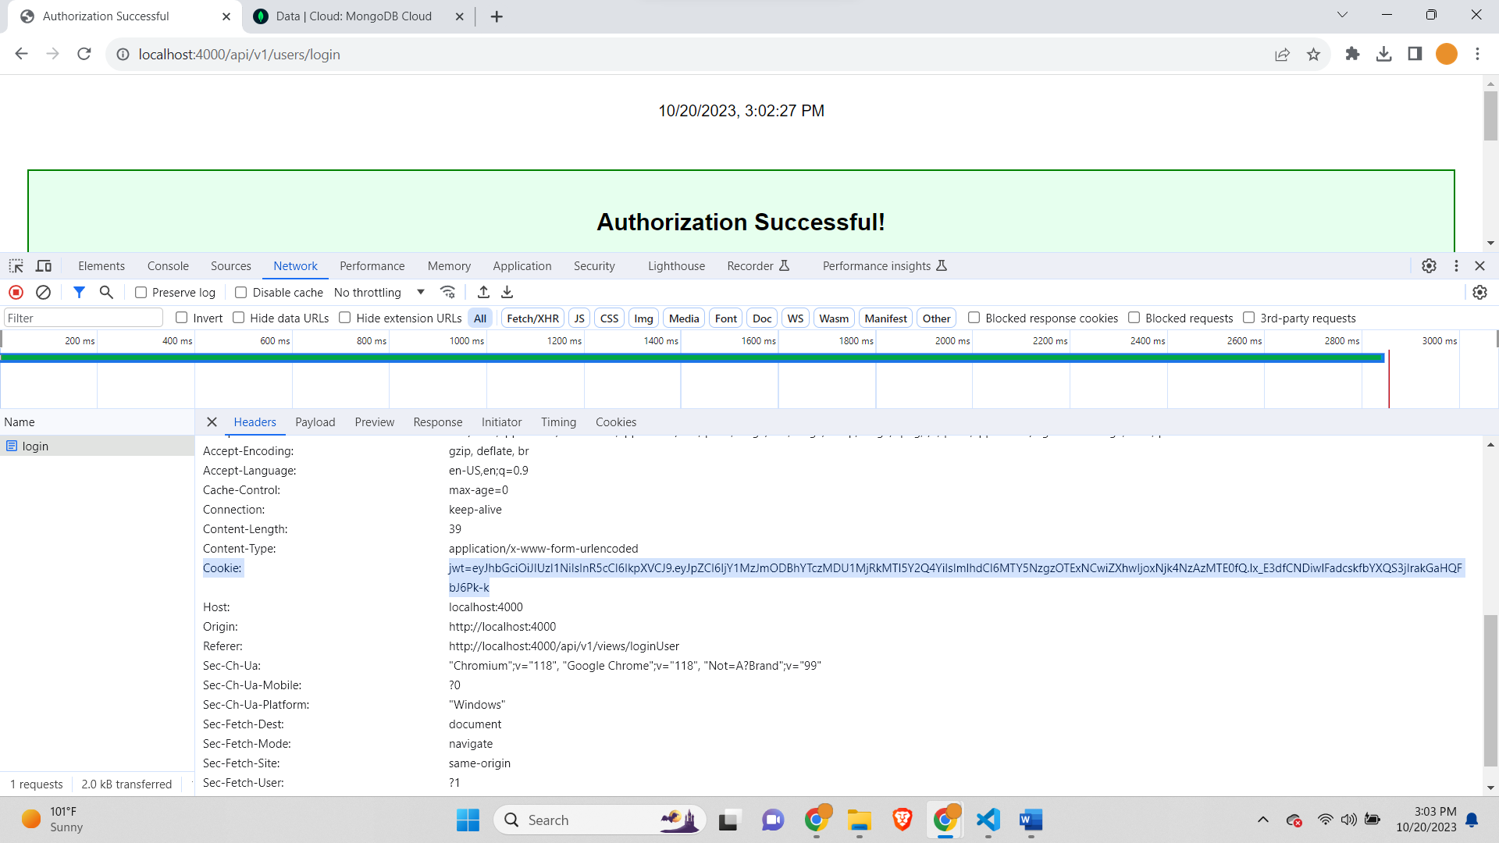

User output-

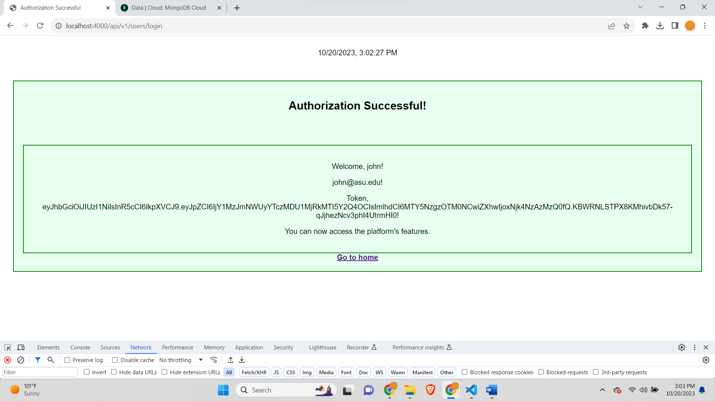

**Task 3: Take a screenshot and Copy the JWT Token**

Response token-

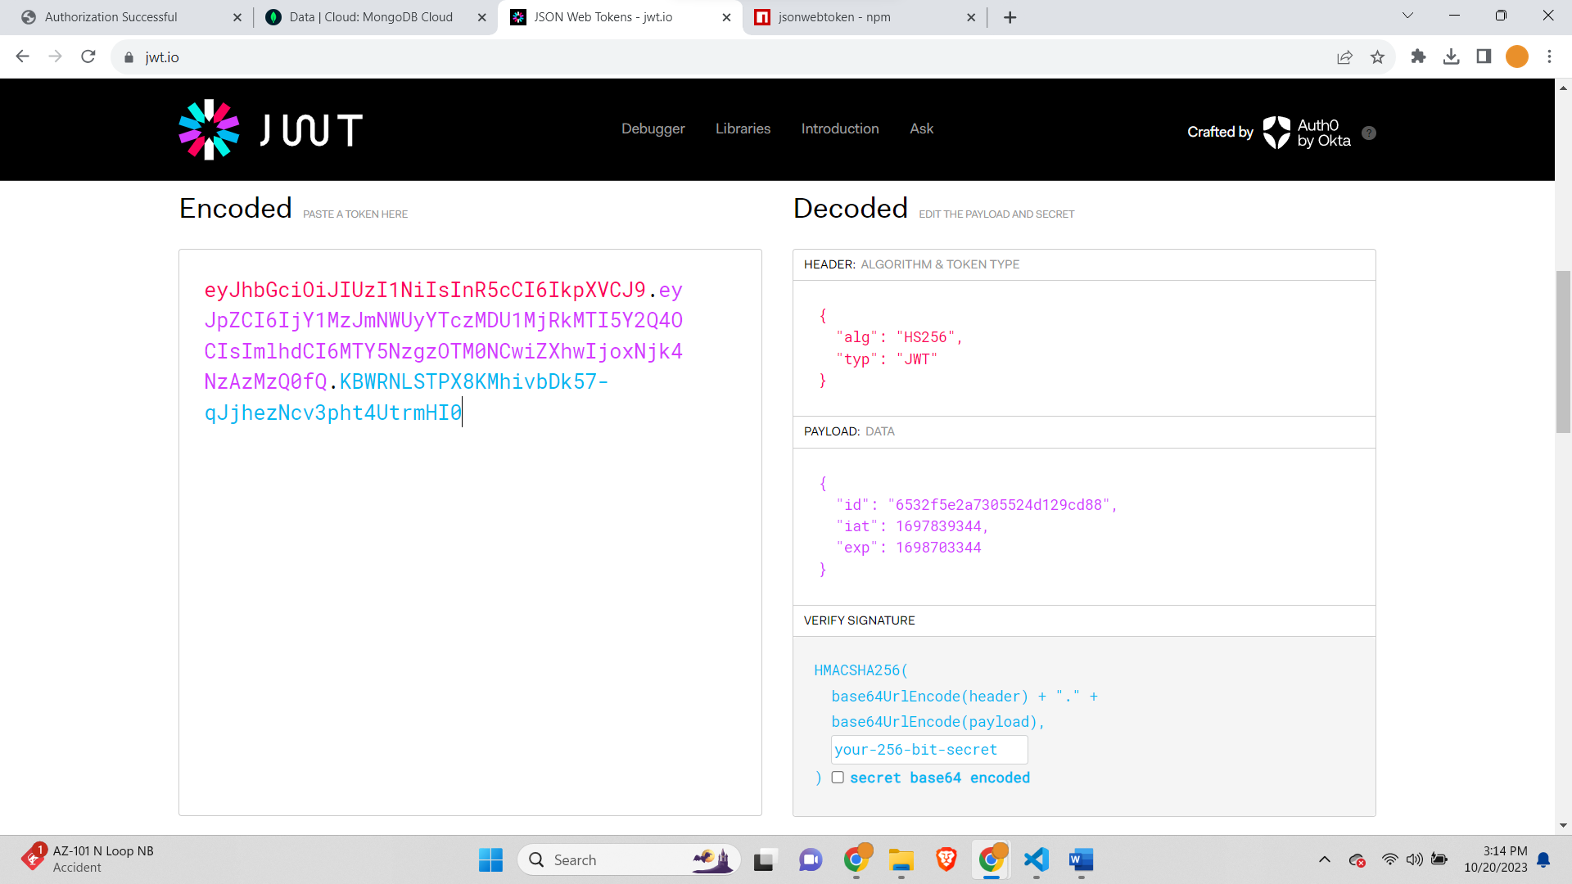

Request token-

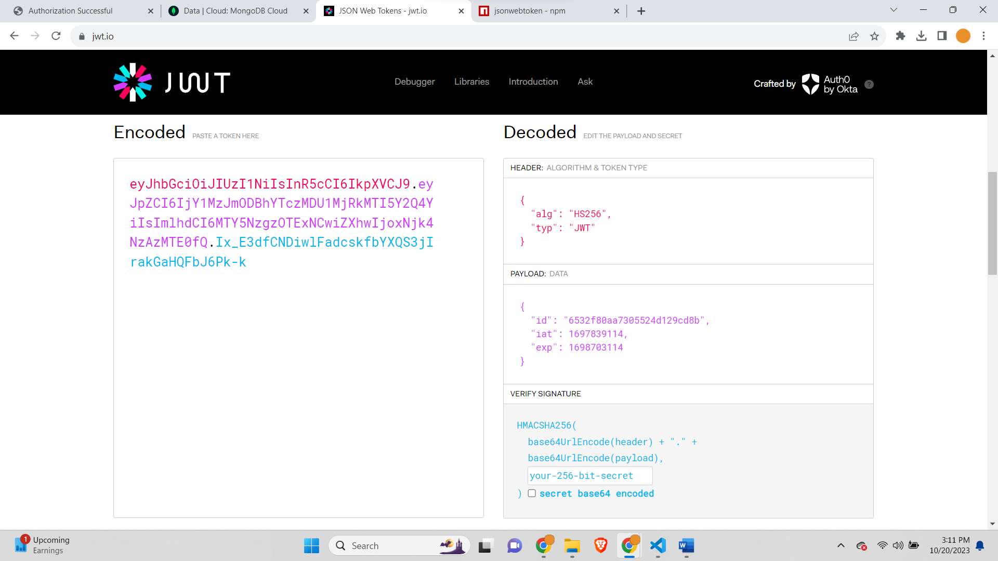

**Conclusion**

* Explain the value of using the Model-View-Controller (MVC) architecture in the context of application security.

Ans- The Model-View-Controller (MVC) architecture provides significant value in the context of application security for the following reasons:

1. **Separation of Concerns**: MVC enforces a clear separation between the different components of an application, namely the Model (data and business logic), View (user interface), and Controller (user input processing and application flow). This separation makes it easier to isolate and manage security-related concerns separately from other application functions. Security can be implemented and updated independently of other features, reducing the risk of security vulnerabilities creeping in through code changes in other areas.
2. **Reusability**: Security modules and features can be developed as reusable components within the MVC framework. This reusability reduces the likelihood of inconsistencies and vulnerabilities in the security implementation. For example, authentication and authorization logic can be reused across various parts of the application, ensuring a consistent and secure approach to user access.
3. **Modular Security Layers**: The MVC architecture encourages the creation of distinct security layers within the application. The Controller component, in particular, is an ideal place to implement security-related functionality, such as user authentication and input validation. These security layers can be designed to interact seamlessly with the rest of the application, providing a consistent and standardized approach to security.
4. **Input Validation**: MVC promotes the implementation of input validation in the Controller component, which is vital for preventing common security vulnerabilities like SQL injection, Cross-Site Scripting (XSS), and Cross-Site Request Forgery (CSRF). By centralizing input validation within the Controller, you can ensure that all user inputs are properly sanitized and validated before they are processed by the Model.
5. **Testing and Validation**: Each component of the MVC architecture can be separately tested, which is crucial for security testing. You can create specific unit tests and integration tests focused on the Controller and Model to verify security features and functionality. This approach helps identify and address security vulnerabilities early in the development process, reducing the risk of deploying an insecure application.

* How did you secure applications from both a configuration and code perspective?

Ans- In this assignment, the approach to securing the application involved both configuration and code-related measures. First, in the configuration aspect, the database connection string and other sensitive data were stored in a separate **config.env** file, which is not included in version control systems, ensuring that sensitive credentials like MongoDB credentials and JWT secrets are kept secure. Additionally, we were instructed to utilize environment variables or secrets management tools when deploying the application, enhancing security at the configuration level. In terms of code security, the assignment involved setting up debugging breakpoints to analyze the application's behavior and understand how it handles user data, which is crucial for identifying and addressing potential security vulnerabilities. By closely inspecting each breakpoint, we could gain insights into how data is processed and validated at different stages of the application, enhancing code security through rigorous testing and debugging. Furthermore, the assignment emphasized the importance of validating JWT tokens and provided instructions for decoding and inspecting token content, contributing to code security by ensuring the proper implementation of user authentication and authorization mechanisms. Overall, the combination of securing sensitive configurations and performing in-depth code analysis through debugging and token validation helps fortify the application from both configuration and code perspectives, enhancing its overall security.